IUPAC Task Group on Atmospheric Chemical Kinetic Data Evaluation – Data Sheet ROO_2
Datasheets can be downloaded for personal use only and must not be retransmitted or disseminated either electronically or in hardcopy without explicit written permission. The citation for this data sheet is: IUPAC Task Group on Atmospheric Chemical Kinetic Data Evaluation, (http://iupac.pole-ether.fr).
This datasheet last evaluated: June 2018; last change in preferred values: June 2018.

C₂H₅O₂ + NO → C₂H₅O + NO₂ (1)
C₂H₅O₂ + NO + M → C₂H₅ONO₂ + M (2)

ΔH°(1) = -45.2 kJ·mol⁻¹
ΔH°(2) = -217.0 kJ·mol⁻¹

Rate coefficient data (k = k₁ + k₂)

k/cm³ molecule⁻¹ s⁻¹ | Temp./K | Reference | Technique/ Comments
Absolute Rate Coefficients
(2.7 ± 0.2) × 10⁻¹² | 298 | Adachi and Basco, 1979 | FP-AS
(8.9 ± 3.0) × 10⁻¹² | 295 | Plumb et al., 1982 | DF-MS
(8.5 ± 1.2) × 10⁻¹² | 298 | Sehested et al., 1993 | PR-AS
(8.2 ± 1.6) × 10⁻¹² | 295 | Däele et al., 1995 | DF-MS (a)
2.6 x 10⁻¹² exp[(380 ± 70)/T] | 207-403 | Eberhard and Howard, 1996 | F-CIMS (b)
(9.3 ± 1.6) × 10⁻¹² | 298
3.1 × 10⁻¹² exp[(330 ± 110)/T] | 220-355 | Maricq and Szente, 1996 | PLP-AS (c)
(10.0 ± 1.5) × 10⁻¹² | 295
3.8 x 10⁻¹² exp[(290 ± 110)/T] | 213-299 | Ranschaert et al., 2000 | F-CIMS (d)
(10.1 ± 0.9) × 10⁻¹² | 299
(11 ± 0.8) × 10⁻¹² | 298 | Xing et al., 2004 | LP-MS (e)
1.75 × 10⁻¹² exp[(462 ± 19)/T] | 203-298 | Bardwell et al., 2005 | F-CIMS (f)
(8.03 ± 0.35) × 10⁻¹² | 298
Branching Ratio
k₂/k ≤ 0.014 (1 bar) | 299 | Atkinson et al., 1982 | (g)
k₂/k = 1.2× 10⁻³ exp(610/T) | 213-298 | Ranschaert et al., 2000 | (h)
k₂/k = 6 × 10⁻³ (100 Torr N₂) | 298
k₂/k = 20 × 10⁻³ (100 Torr N₂) | 213
k₁/k = 1.0 ± 0.05 (133-266 mbar N₂) | 203-298 | Bardwell et al., 2005 | F-CIMS (f)
k₂/k₁ = (7.4 ± 1) × 10⁻³ (100 Torr N₂) | 298 | Butkovskaya et al., 2010 | F-CIMS (i)
k₂/k₁ = (26.8 ± 3.4) × 10⁻³ (600 Torr N₂)
k₂/k₁ = 72.2 × 10⁻³ (600 Torr N₂) | 223

Comments

(a) Conventional discharge flow system with LIF detection of C₂H₅O product. k determined by simulation of experimental C₂H₅O profiles.
(b) Ethylperoxy radicals formed by the thermal decomposition of n-propyl nitrate in the presence of O₂, or by RF discharge through C₂H₅I (also in the presence of O₂). Pseudo first order kinetics with excess NO and CIMS detection of C₂H₅O₂ as the ethyl peroxy negative ion.
(c) Excimer laser photolysis of Cl₂-C₂H₆-NO-O₂-N₂ mixtures. Time-resolved measurements of C₂H₅O₂ decay and C₂H₅ONO formation using diode array UV absorption spectroscopy, and of NO loss and NO₂ formation using diode laser absorption spectroscopy.
(d) Turbulent flow reactor at 100 Torr (133 mbar) N₂ total pressure. C₂H₅O₂ detected as C₂H₅OOH⁺(H₂O)_{n} and C₂H₅ONO₂ detected as C₂H₅ONO₂H⁺(H₂O)_{n} following proton transfer from H₃O⁺.
(e) C₂H₅O₂ generated by reaction of C₂H₅ with O₂, whereby C₂H₅ radicals were generated in the 248 nm photolysis of C₂H₅I, the 193 nm photolysis of C₂H₅Br or the 193 nm photolysis of CCl₄ in the presence of ethane. Owing to poor sensitivity, the experiments could not be performed under pseudo first-order conditions, and the data obtained using CCl₄ are reported to be less reliable as a result of secondary chemistry. C₂H₅O₂ was detected as the negative parent ion following electron transfer from high Rydberg state rare gas atoms. The bath gas was 5.3 mbar He and 0.8 mbar O₂.
(f) Turbulent flow reactor at 133 or 266 mbar N₂ total pressure. C₂H₅O₂ was generated in the reaction Cl + C₂H₆ (+O₂) and detected as C₂H₅O₂⁻ following electron transfer from SF₆⁻. Yield of NO₂ (detected as NO₂⁻) was found to be 1.0 ± 0.05.
(g) GC analysis of C₂H₅ONO₂ product from photo-oxidation of C₂H₆ in Cl₂-C₂H₆-NO-air mixtures.
(h) Temperature dependent values of the rate coefficient k₂ = 1.6 × 10⁻¹⁵ exp (1160/T) for the temperature range 213 to 299 K and 100 Torr (133 mbar) N₂ pressure also presented. The authors state that the branching ratios are associated with large errors as the measurements were conducted near the detection limit for C₂H₅ONO₂ and were complicated by secondary chemistry.
(i) Turbulent flow reactor with CIMS detection of products. Branching ratios (k₂ / k₁) were derived from monitoring the formation of C₂H₅ONO₂ relative to either NO₂, C₂H₅ONO or CH₃CHO, the latter two both arising from reactions of alkoxy radical co-product of NO₂ in reaction (1). The in-situ calibration of C₂H₅ONO₂ and C₂H₅ONO was via formation of C₂H₅O at known yield (0.55) in the reaction of F atoms with C₂H₅OH and its further reactions with NO₂ or NO, respectively. Consistent results were reported when using NO₂, C₂H₅ONO or CH₃CHO as a measure of the flux through reaction (1).

Parameter | Value | T/K
k /cm³ molecule⁻¹ s⁻¹ | 9.1 × 10⁻¹² | 298
k /cm³ molecule⁻¹ s⁻¹ | 2.55 × 10⁻¹² exp(380/T) | 200-410
k₂/k * | (1/(0.01 × (1.18e-19 ×[M]+0.365) × (1+900 × (1/T-1/298)))+1)⁻¹
k₂/k (1 bar) | 0.033 | 298 K
Reliability
Δ log k | ± 0.1 | 298
Δ E/R | ± 50 | 200-410
Δ log (k₂/k) | ± 0.2 | 220-320
*The expression was adapted from the parameterization for k₂/k₁ given by Butkovskaya et al. (2010) using k₂/k = (k₁/k₂ +1)⁻¹.

Preferred Values

Comments on Preferred Values

With the exception of the measurement of Adachi and Basco (1979), all measurements at room temperature are in reasonable agreement. The preferred value of the rate coefficient at room temperature is an average of the data from the direct studies of Plumb et al. (1982), Eberhard and Howard (1996), Ranschaert et al. (2000) and Bardwell et al. (2005). The temperature coefficients (E/R) also show good agreement and the preferred value was obtained from a weighted fit to the data of Eberhard and Howard (1996), Ranschaert et al. (2000) and Bardwell et al. (2005). The data of Maricq and Szente (1996) are consistent with these datasets, but significantly more scattered.

The observation of a temperature independent, (100 ± 5)% yield of NO₂ confirms that the reaction proceeds predominantly via formation of an alkoxy radical + NO₂ under atmospheric conditions (Bardwell et al., 2005), with low yields of C₂H₅ONO₂ at room temperature (Atkinson et al., 1982). However, the work of Ranschaert et al. (2000) and Butkovskaya et al, (2010) indicate that the yield of C₂H₅ONO₂ increases with increasing pressure and decreasing temperature. The extensive experiments of Butkovskaya et al. (2010), covering temperatures between 222 and 323 K and pressures between 100 and 600 Torr, enabled the authors to derive a pressure and temperature dependent expression for k₂/k₁, which reproduces their own data and is roughly consistent with the observations of Raenschaert et al (2000). The data of Butkovykaya et al (2010) are reasonably consistent with predictions of temperature dependent nitrate formation in C₂H₅O₂ + NO extrapolated from larger RO₂ (Carter and Atkinson, 1985) but not with latter recommendations from the same group (Carter and Atkinson, 1989, Arey et al., 2001).

We have adopted the parameterisation of Butkovykaya et al (2010) as our preferred branching ratio for ethyl-nitrate formation, but have expanded the uncertainty to account for the difference between their results at one bar and room temperature compared to Atkinson et al. (1982).

References

Adachi, H. and Basco, N.: Chem. Phys. Lett. 64, 431, 1979.
Atkinson, R., Aschmann, S. M., Carter, W. P. L., Winer, A. M. and Pitts, Jr., J. N.: J. Phys. Chem. 86, 4563, 1982.
Arey, J., Aschmann, S. M., Kwok, E. S. C., and Atkinson, R., J. Phys. Chem A, 105, 1020-1027, 2001.
Bardwell, M. W., Bacak, A., Raventós, M. T., Percival, C. J., Sanchez-Reyna, G. and Shallcross, D. E.: Int. J. Chem. Kinet. 37, 253, 2005.
Butkovskaya, N., Kukui, A., and Le Bras, G., J. Phys. Chem. A, 114, 956-964, 2010.
Carter, W. P. L and Atkinson, R., J. Atmos. Chem. 3, 377, 1985.
Carter, W. P. L and Atkinson, R., J. Atmos. Chem. 8, 165, 1989.
Däele, V., Ray, A., Vassalli, I., Poulet, G. and Le Bras, G. Int. J. Chem. Kinet. 27, 1121, 1995.
Eberhard, J. and Howard, C. J.: Int. J. Chem. Kinet. 28, 731, 1996.
Maricq, M. M. and Szente, J. J.: J. Phys. Chem. 100, 12374, 1996.
Plumb, I. C., Ryan, K. R., Steven, J. R. and Mulcahy, M. F. R.: Int. J. Chem. Kinet. 14, 183, 1982.
Ranschaert, D. L., Schneider, N. J. and Elrod, M. J.: J. Phys. Chem. A 104, 5758, 2000.
Sehested, J., Nielsen, O. J. and Wallington, T. J.: Chem. Phys. Lett. 213, 457, 1993.
Xing, J.-H., Nagai, Y., Kusuhara, M and Miyoshi, A.: J. Phys. Chem. A 108, 10458, 2004.

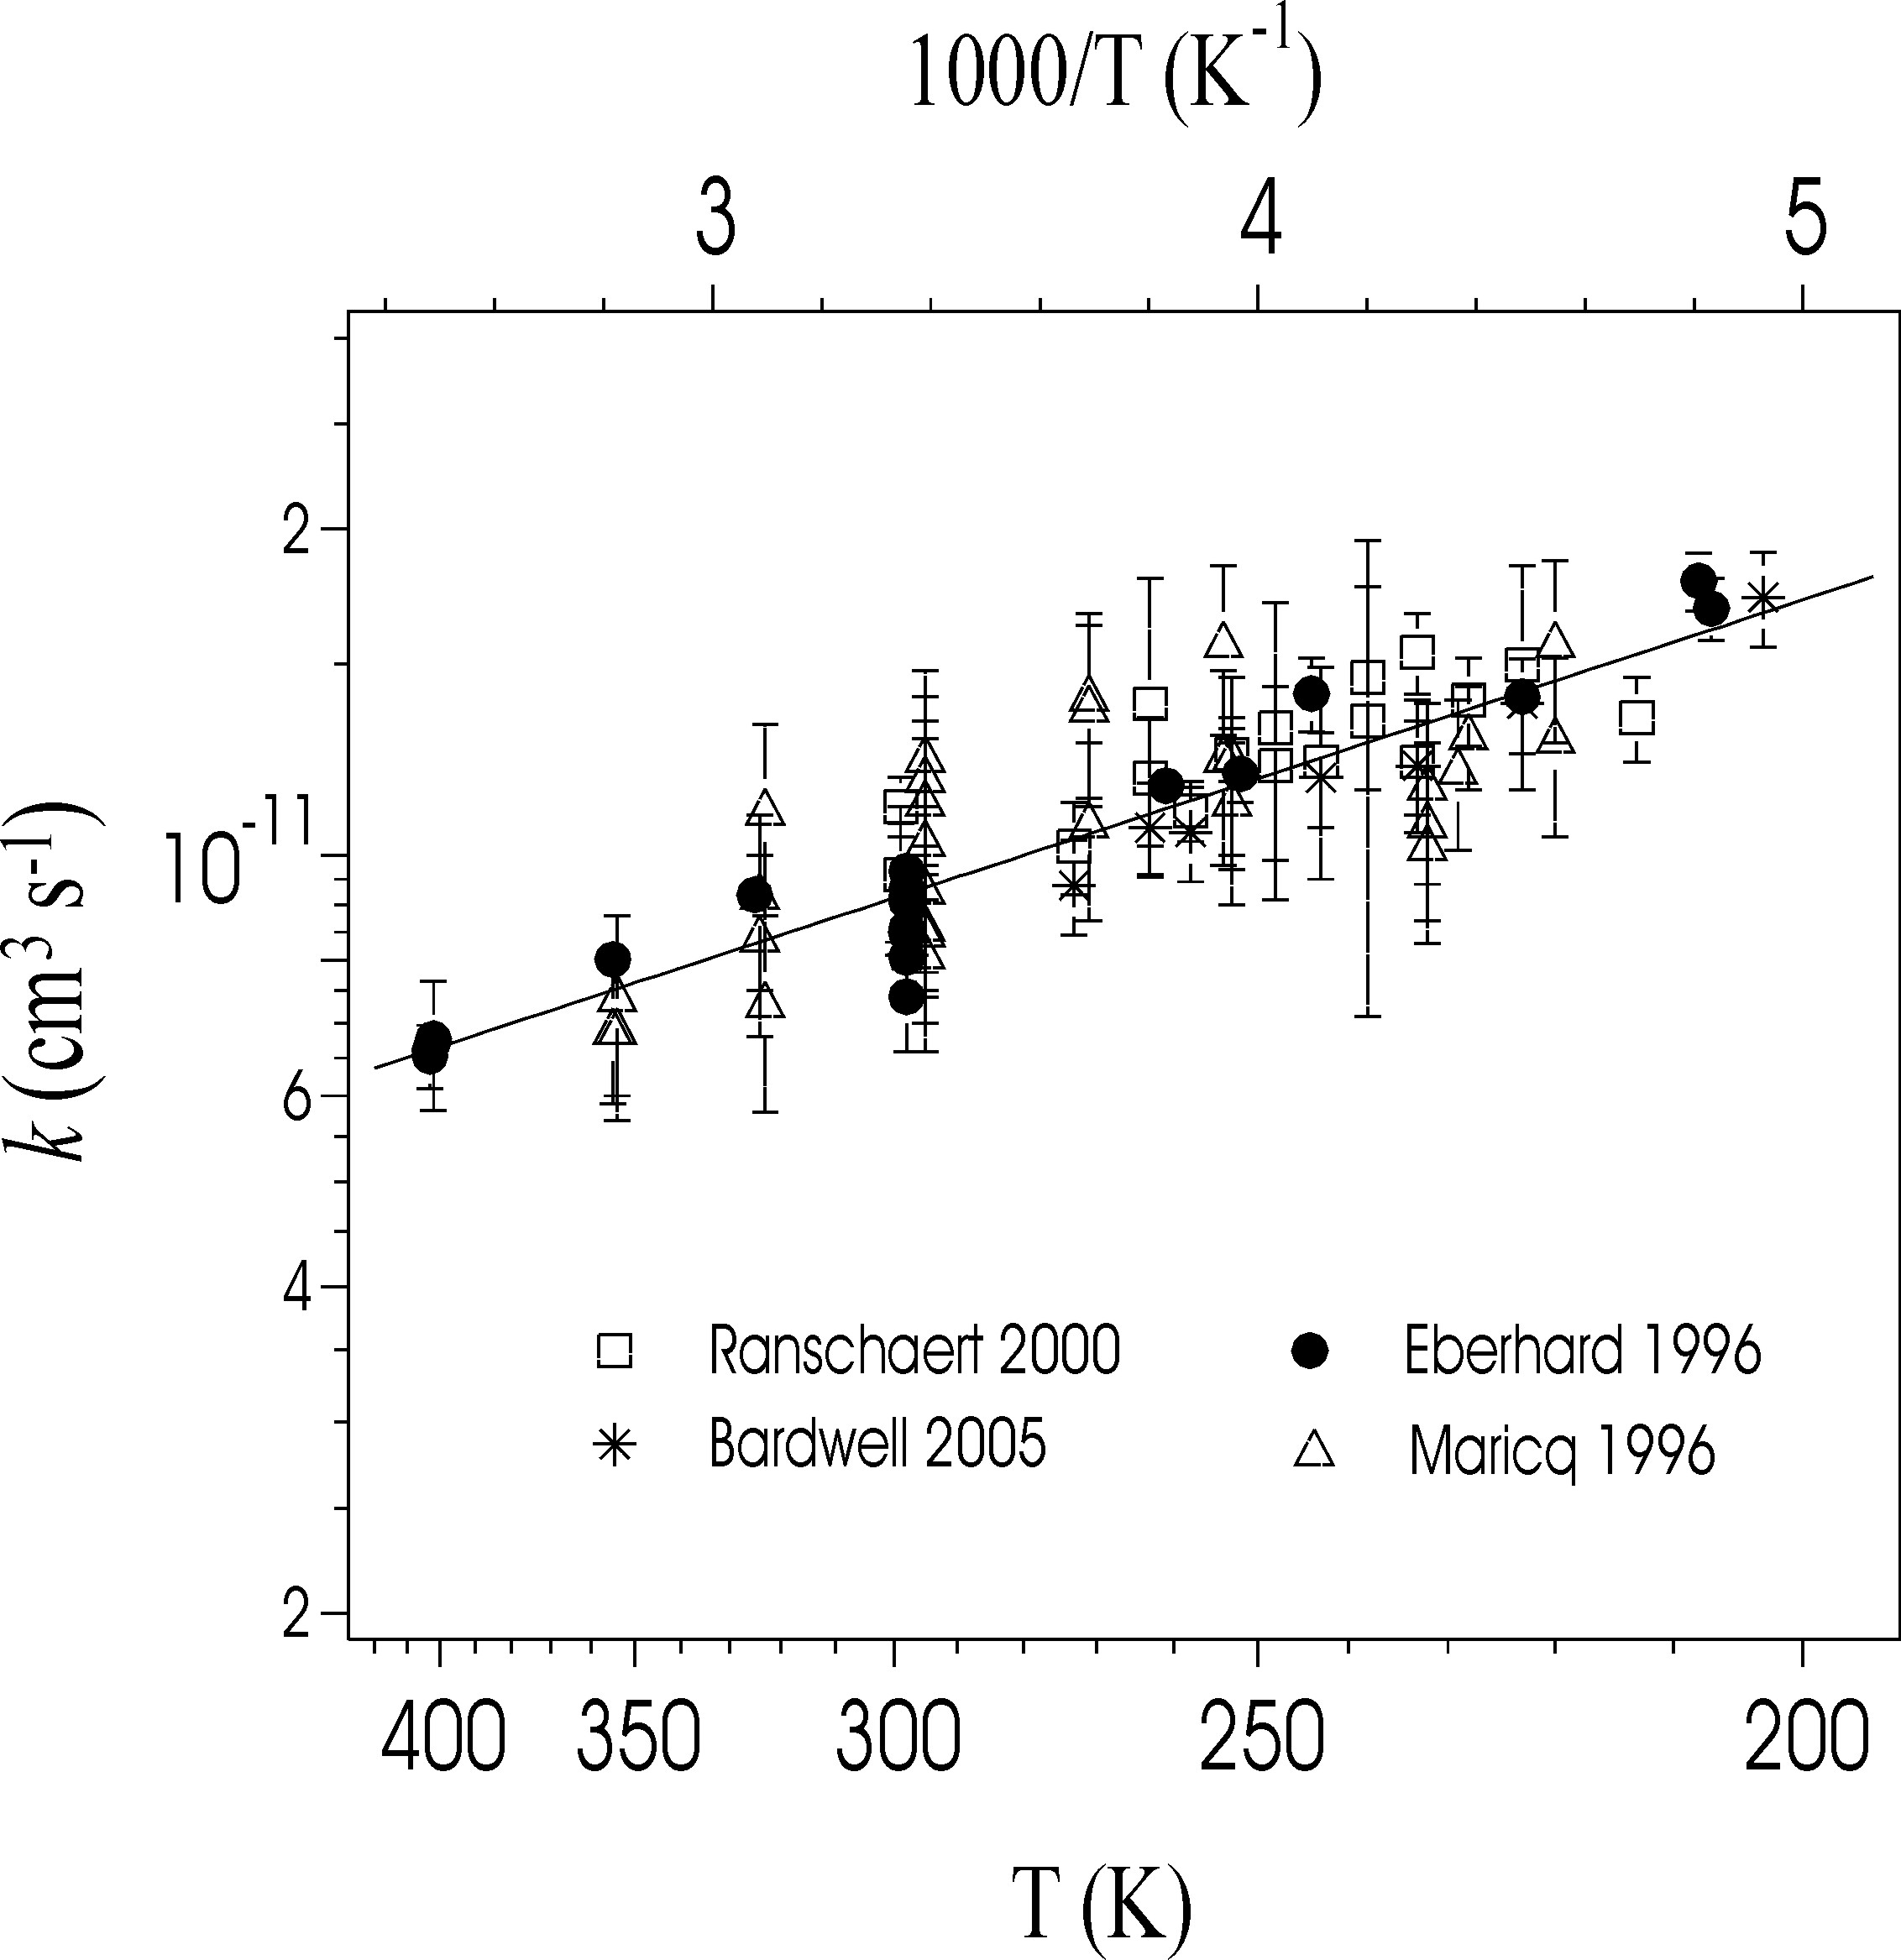

Rate coefficients (k) for C₂H₅O₂ + NO. The solid line is the IUPAC preferred value.

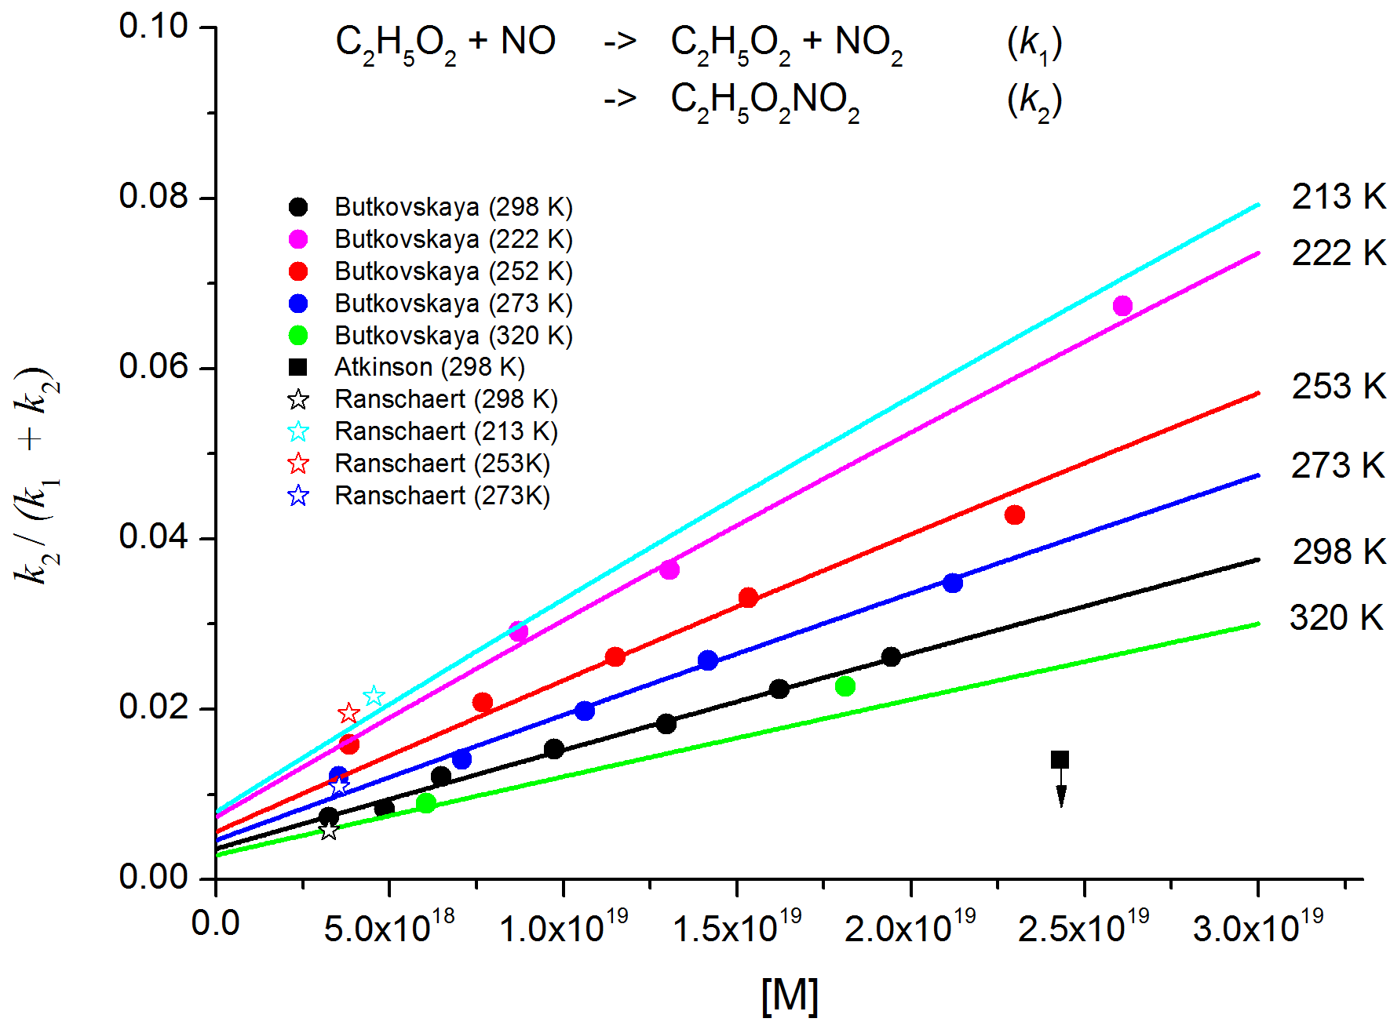

Branching ratio, k₂ / (k₁+k₂), for formation of C₂H₅ONO₂ in the reaction between C₂H₅O₂ and NO. The solid lines are adapted from the parameterisation given by Butkovykaya et al. (2010). To preserve clarify of presentation, only selections of the datasets of Butkovskaya et al. (2010) and Ranschaert et al. (2000) are shown. The down-arrow on the data point of Atkinson (1982) indicates an upper-limit.

