IUPAC Task Group on Atmospheric Chemical Kinetic Data Evaluation
– Data Sheet AQ_TH1_OH_3
Datasheets can be downloaded for personal use only and must not be retransmitted or disseminated either electronically or in hardcopy without explicit written permission.
The citation for this datasheet is: IUPAC Task Group on Atmospheric Chemical Kinetic Data Evaluation, http://iupac.pole-ether.fr.
This datasheet last evaluated: May 2016; last change in preferred values: May 2016

OH·(aq) + CH(OH)₂COOH(aq) → ·C(OH)₂COOH + H₂O (1)
OH·(aq) + CH(OH)₂COO⁻(aq) → ·C(OH)₂COO⁻ + H₂O (2)

ΔG_{R}° (aq): Aqueous phase thermochemical data not available. Gas phase data for comparison also not available.

Rate coefficient data

k/ L mol⁻¹ s⁻¹ | T/K | pH | I/ mol L⁻¹ | Reference | Technique/ Comments
Relative Rate Coefficients
k₁ = (3.6 ± 0.2) × 10⁸ | 298 | 1 |  | Ervens et al. 2003 |  | LP(a)
k₁ = 8.1 × 10⁹ exp[- (1000 ± 400) / T] | 288 - 328
k₂ = (2.6 ± 0.9) × 10⁸ | 298 | 8
k₂ = 6.0 × 10¹⁵ exp[- (4500 ± 800) / T] | 288 - 328

Glyoxylic acid is hydrated in water, as shown in the following equation:

CHOCOOH + H₂O (1) → CH(OH)₂COOH(aq) with K = 5.4 M⁻¹, (Sørensen et al., 1974)

pKa value for glyoxylic acid can be found in Lide (1996) (pK_{a} = 3.18).

Comments

- Laser photolysis of H₂O₂ (c = 5 × 10⁻⁴ M, λ = 248 nm); pH adjusted to pH = 1 by HClO_{4.} Analysis light at λ = 436 nm; Reference reaction (RR): ·OH + SCN⁻; rate constant is given by k(T) = 7.26 × 10¹² exp[(-1900 ± 190) / T] M⁻¹s⁻¹ after Chin and Wine (1992) (at pH = 6).

Preferred Values

Parameter | Value | T/K
k₁ / l mol⁻¹ s⁻¹ | 3.6 × 10⁸ | 298
k₁ / l mol⁻¹ s⁻¹ | 8.1 × 10⁹ exp[- (1000) / T] | 293-353
k₂ / l mol⁻¹ s⁻¹ | 2.6 × 10⁸ | 298
k₂ / l mol⁻¹ s⁻¹ | 6.0 × 10¹⁵ exp[- (4500) / T] | 293-353

Reliability
Δ log k₁ | ± 0.02 | 298
Δ E_{A1}/R | ± 400 | 293-353
Δ log k₂ | ± 0.16 | 298
Δ E_{A2}/R | ± 800 | 293-353

Comments on Preferred Values

These are the only available kinetic data on these reactions.

References

Chin, M., and Wine, P. H: J. Photochem. Photobiol., A, 69(1), 17-25, 1992.

Ervens, B., Gligorovski, S. and Herrmann, H.: Phys. Chem. Chem. Phys., 5(9), 1811-1824, 2003.

Lide, D.R.: “CRC Handbook of Chemistry and Physics”, 76th Ed., CRC Press, Boca Raton, 1996.

Sørensen, P. E.; Bruhn, K. and Lindelov, F.: Acta Chem. Scand., 28(2), 162 - 168 , 1974.

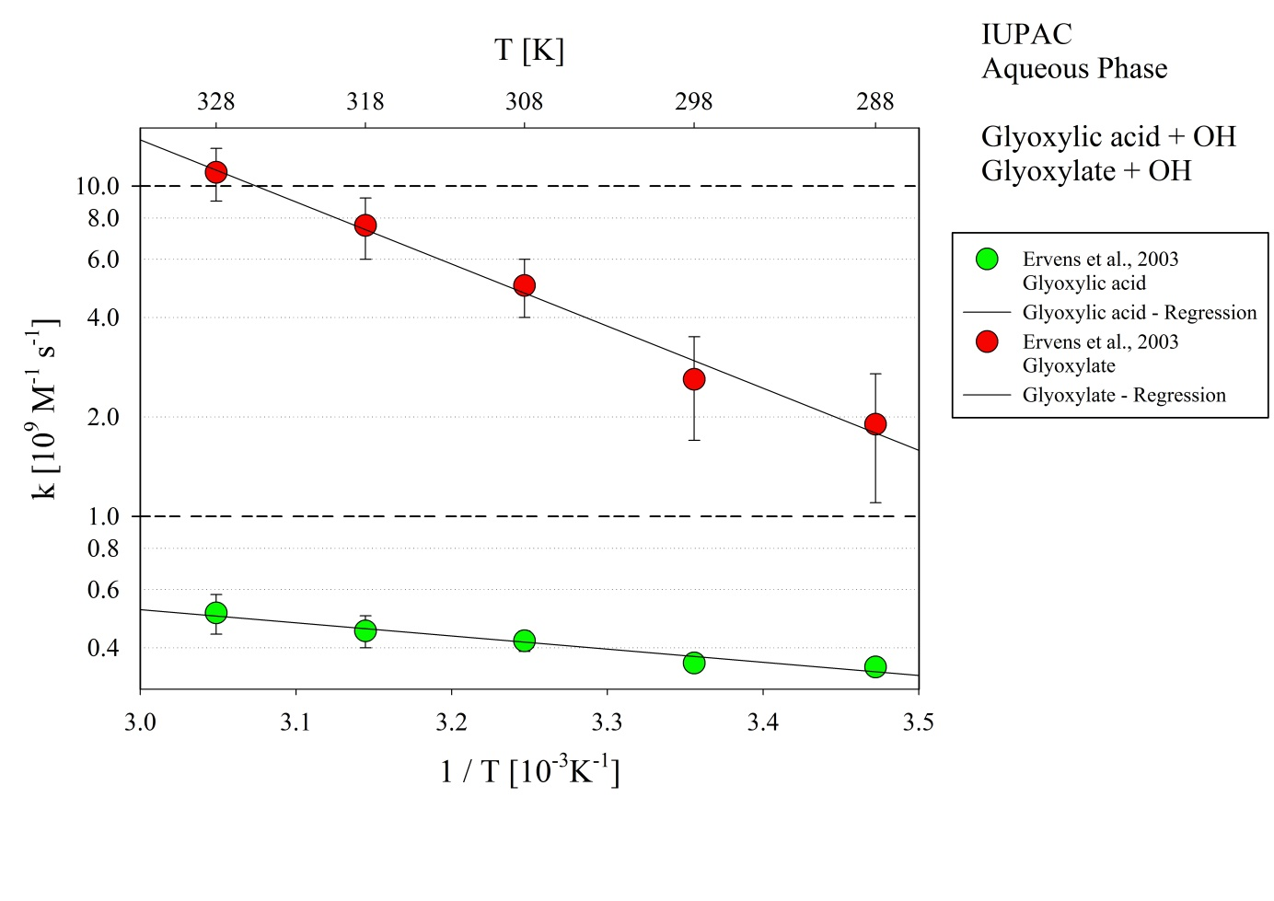
Figure 1: T-dependent rate constants for the reaction of glyoxylic acid and glyoxylate with OH in aqueous solution. Data from Ervens et al. (2003).

