IUPAC Task Group on Atmospheric Chemical Kinetic Data Evaluation
– Data Sheet AQ_TH1_OH_1
Datasheets can be downloaded for personal use only and must not be retransmitted or disseminated either electronically or in hardcopy without explicit written permission.
The citation for this datasheet is: IUPAC Task Group on Atmospheric Chemical Kinetic Data Evaluation, http://iupac.pole-ether.fr.
This datasheet last evaluated: May 2017; last change in preferred values: May 2016

OH·(aq) + [CH(OH)₂]₂(aq) → ·C(OH)₂CH(OH)₂ + H₂O (l)
Aqueous phase thermochemical data not available. Thermochemical gas phase data for comparison also not available because of the hydration of glyoxal in aqueous solution.

Rate coefficient data

k/ L mol⁻¹ s⁻¹ | T/K | pH |  | I/ mol L⁻¹ |  | Reference | Technique/ Comments
Relative Rate Coefficients
6.6 × 10⁷ | 298 | 1.3 |  |  |  | Buxton et al., 1988 |  | (a)
(1.10 ± 0.04) × 10⁹ | 293 | 2.0 – 6.0 |  |  |  | Buxton et al., 1997 |  | PR-UV/Vis (b1)
(1.10 ± 0.1) × 10⁹ | 293 | 4 |  |  |  |  |  | PR-UV/Vis (b2)
1.9 × 10¹¹ exp[(-1516 ± 30)/T] | 279 - 319 | 4
(9.4 ± 0.4) × 10⁸ | 298 | 2.0 |  |  |  | Schaefer et al., 2015 |  | LFP (c)
(9.2 ± 0.5) × 10⁸ | 298 | 6.0
(1.1 ± 0.1) × 10⁹ | 298 | 9.0
5.8 × 10¹⁰ exp[(-1200 ± 120)/T] | 278 - 318 | 6.0

Comments

- Buxton et al. refers to a value determined by Draganic and Marcovic (1968, unpublished work) in their review, relative to ·OH + oxalic acid; for the rate constant of oxalic acid, Buxton et al. recommends k(·OH + oxalic acid) = 1.4 × 10⁹ M⁻¹ s⁻¹; these values are also given in the NIST database.
http://kinetics.nist.gov/solution/Detail?id=1968DRA/MARB:1

- Measured in N₂O-saturated solution; competition kinetics; reference reaction: ·OH + Fe(CN)₆⁴⁻ with k(·OH + Fe(CN)₆⁴⁻) = 1.0 × 10¹⁰ M⁻¹ s⁻¹ (Buxton et al., 1988); measured at λ = 420 nm; the rate constant has been confirmed by direct observation; temperature dependent data was gathered via direct observation with no specific values for k(T) given; activation energy is given as E_{A} = (12.6 ± 0.9) kJ mol⁻¹; Arrhenius expression was calculated using the given data; reviewed by Schaefer et al. (2015).

- Reference reaction (RR): ·OH + SCN⁻; rate constant is given by k(T) = 7.26 × 10¹² exp[(-1900 ± 190) / T] M⁻¹s⁻¹ according to Chin and Wine (1992) (at pH = 6). An activation energy E_{A} of (12.6 ± 0.9) kJ mol⁻¹ was obtained from direct measurements of k.

Preferred Values

Parameter | Value | T/K
k / l mol⁻¹ s⁻¹ | 9.2 × 10⁸ | 298
k / l mol⁻¹ s⁻¹ | 5.8 × 10¹⁰ · exp[- (1200)/T] | 278 - 318

Reliability
Δ log k | ± 0.390 | 298
Δ E_{A}/R | ± 120 | 278 - 318

Comments on Preferred Values
The recent T-dependent determination by Schaefer at al. (2015) leads to a slightly lower rate constant than suggested by Buxton et al. in the first determination of this rate constant when the data for pH 6 are compared. The value previously recommended by Buxton et al. (1988) as determined by Draganic and Marcovic (1968, unpublished) is not confirmed by the later determinations.

References

Adams, G. E., and R. L. Willson: Trans. Faraday Soc., 65, 2981-2987, 1969.

Buxton, George V., Malone, T. N. and Salmon, G. Arthur: J. Chem. Soc., Faraday Trans., 93, 2889-2891, 1997.

Chin, M., and Wine, P. H: J. Photochem. Photobiol., A, 69(1), 17-25, 1992.

Ervens, B., and Volkamer, R.: Atmos. Chem. Phys., 10 (17), 8219 – 8244, 2010.

Schaefer, T., van Pinxteren, D., and Herrmann, H.: Environ. Sci. Technol., 49, 343 – 350, 2015.

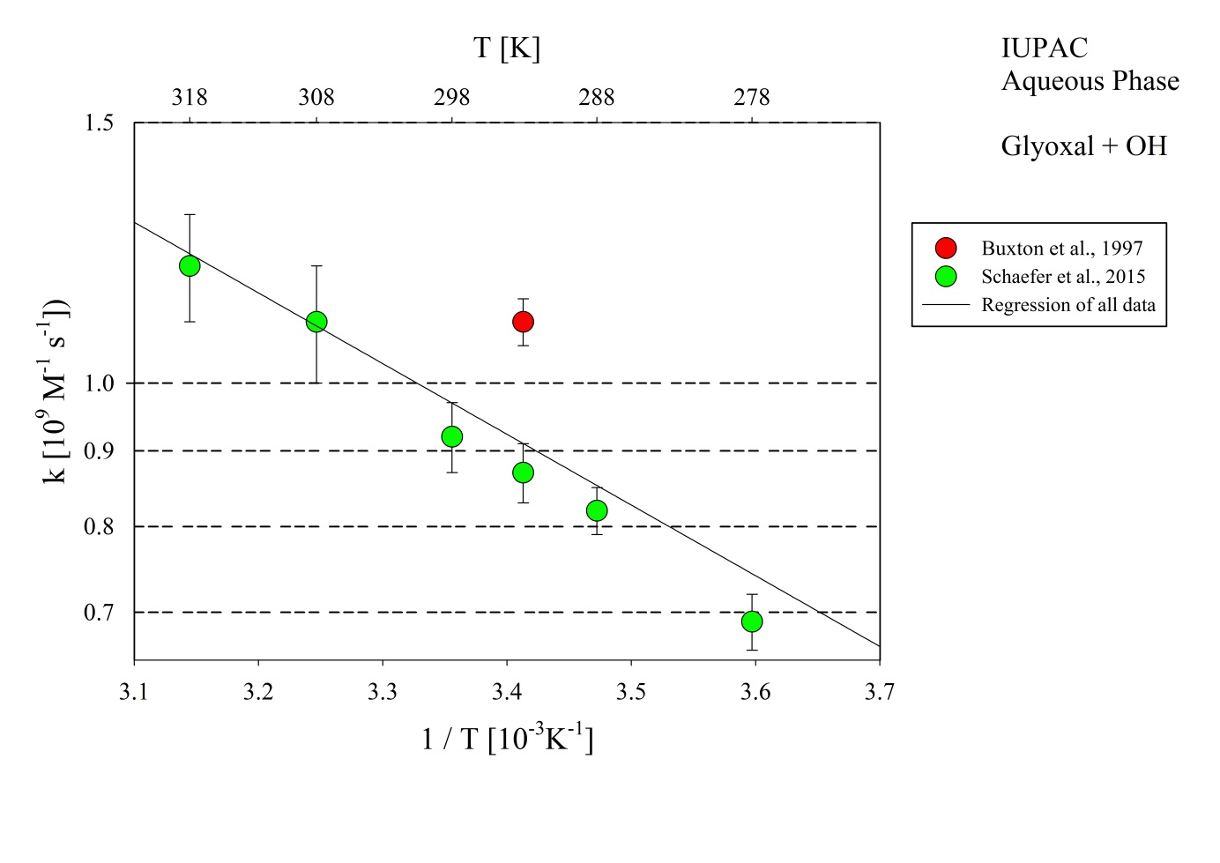
Figure 1: T-dependent rate constants for the reaction of glyoxal with OH in aqueous solution.
Data from Buxton et al. (1997) and Schaefer et al. (2015).

