IUPAC Task Group on Atmospheric Chemical Kinetic Data Evaluation
– Data Sheet AQ_TH1_NO3_4
Datasheets can be downloaded for personal use only and must not be retransmitted or disseminated either electronically or in hardcopy without explicit written permission.
The citation for this datasheet is: IUPAC Task Group on Atmospheric Chemical Kinetic Data Evaluation, http://iupac.pole-ether.fr.
This datasheet last evaluated: May 2017; last change in preferred values: May 2017

NO₃·(aq) + (COOH)₂(aq) → ·OOC-COOH(aq) + HNO₃ (1)
NO₃·(aq) + ⁻OOC-COOH(aq) → ·OOC-COOH(aq) + NO₃⁻(aq) (2)
NO₃·(aq) + ⁻OOC-COO⁻ (aq) → ·OOC-COO⁻(aq) + NO₃⁻(aq) (3)

ΔG_{R}° (aq): Aqueous phase thermochemical data not available. Gas phase data for comparison also not available.

Rate coefficient data

k / L mol⁻¹ s⁻¹ | T / K |  | pH | I / mol L⁻¹ | Reference | Technique/ Comments
Absolute Rate Coefficients
k₂ = 8.4 × 10⁹ exp[-(2180 ± 660)/T] |  | 278 - 298 | 1 |  | Zellner et al., 1996  Raabe, 1996 | LFP- LPLA (a)
k₂ = (6.1 ± 1.5) × 10⁶ |  | 298 | 1
k₃ = 3.2 × 10¹¹ exp[(-2526 ± 1680)/T] |  | 278 - 298 | 9
k₃ = (2.1 ± 0.6) × 10⁸ |  | 298 | 9
(1.4 ± 0.4) × 10⁸ |  | 298 |  | I → 0 | Herrmann et al., 2003 | LFP- LPLA (b)
(2.0 ± 0.4) × 10⁸ |  |  |  | I → ∞
k₁ = (2.4 ± 0.2) × 10⁴ |  | 298 | <0 |  | Yang et al., 2004 | PR(c)
k₂ = (7.8 ± 0.7) × 10⁷ |  |  | 3
k₃ = (2.2 ± 0.1) × 10⁸ |  |  | 7
k₁ < 5 × 10⁴ |  | 298 |  |  | G. de Semainville et al., 2010 | LFP - Teflon Waveguide/ S₂O₈²⁻(d)
k₂ = (4.4 ± 0.2) × 10⁷
k₃ = (2.2 ± 0.8) × 10⁸ |  |  | 2.7
k₃ = 2.2 × 10¹² exp[(-2766 ± 720)/T] |  | 278 - 298 | 8

Comments

(a) Project report with strongly summarized results from the Ph.D. thesis of Raabe (1996). Measurements at pH = 1 (cf. pK_{a} values from Lide (1996) of 1.23 and 4.19, respectively) have been corrected to obtain the given Arrhenius expression and room temperature rate constant for the reaction of NO₃ with the oxalate mono-anion (k₂). In the cited project report an additional rate constant of k_{obs} = (1.7 ± 0.5) × 10⁸ l mol⁻¹ s⁻¹ for pH = 4 is given. It is important to note that this value is an uncorrected observed rate constant representing a mixture of k₂ and k₃.

(b) The I –effect was studied at pH = 4 and T =298 K (Dissertation G. Raabe, 1996). Reviewed data from Zellner et al. (1996) and Herrmann et al. (1998).

(c) Direct measurement; NO₃ radicals generated by pulse radiolysis of N₂O saturated HNO₃ solution (2.0 M) and Ar saturated NaNO₃ solution (1.0 M); analyzing light: 630 nm; reactions were carried out at ambient temperature.

(d) NO₃ radicals were produced through laser flash photolysis of peroxodisulfate in presence of nitrate anion at 355 nm; He-Ne laser was used as the analyzing light (output wavelength of 633 nm); Liquid core waveguide (LCW) setup (made of Teflon AF 2400) was used. (length of 50 cm / inner volume of 0.25 mL); temperature dependent data for rate constants were used from plotted expression.

Preferred Values

Parameter | Value | T/K
k₁ / l mol⁻¹ s⁻¹ | 2.4 × 10⁴ | 298
k₂ / l mol⁻¹ s⁻¹ | 6.1 × 10⁶ | 298
 | 8.4 × 10⁹ exp[-(2180)/T] | 278 – 298 K
k₃ / l mol⁻¹ s⁻¹ | 1.7 × 10⁷ | 298
 | 1.3 × 10¹² exp[(-2650)/T] | 278 – 298 K

Reliability
Δ log k₁ | ± 0.03 | 298
Δ log k₂ | ± 0.11 | 298
Δ E_{A2}/R | ± 660 | 278 – 298
Δ log k₃ | ± 0.08 | 298
Δ E_{A3}/R | ± 1200 | 278 - 298

Comments on Preferred Values

For the reaction with the undissociated acid the rate constant k₁ by Yang et al. (2004) is recommended. For the reaction with the mono-anion (k₂) the rate constant from the determinations of Zellner et al. (1996) and Raabe (1996) is recommended. Possibly, the higher Yang et al. (2004) and Semainville et al (2010) rate constants might be due to contributions of the faster di-anion reactions. Then, for the reaction with the di-anion (k₃), data of all the three mentioned studies are averaged.
T-dependent data: For the reaction with the mono-anion (k₂) the Arrhenius expression by Zellner et al. (1996) is recommended. For the reaction with the di-anion (k₃), the average T-dependence of Zellner et al. (1996) with Raabe (1996) and de Semainville et al. (2010) is recommended.

References

Herrmann, H.; Zellner, R. In “N-Centered Radicals”. Alfassi, Z. B., Ed.; John Wiley and Sons: New York; pp. 291; 1998.

Herrmann, H.: Chem. Rev., 103 (12), 4691–4716, 2003.

Lide, D.R.: “CRC Handbook of Chemistry and Physics”, 76th Ed., CRC Press, Boca Raton, 1996.

Raabe, G., Dissertation, Essen 1996.

Semainville, Ph. G. de., D'Anna, B. and George, Ch.: Z. Phys. Chem., 224(7-8), 1247 - 1260, 2010.

Yang, X. K., Wang, J. Q. and Wang, T. D.: Chin. Chem. Lett., 15, 583 - 586, 2004.

Zellner, R., Herrmann, H., Exner, M., Jacobi, H.-W., Raabe, G. and Reese, A. In “Heterogeneous and Liquid-Phase Processes”. Warneck, P., Ed.; Springer: Berlin, pp. 146, 1996.

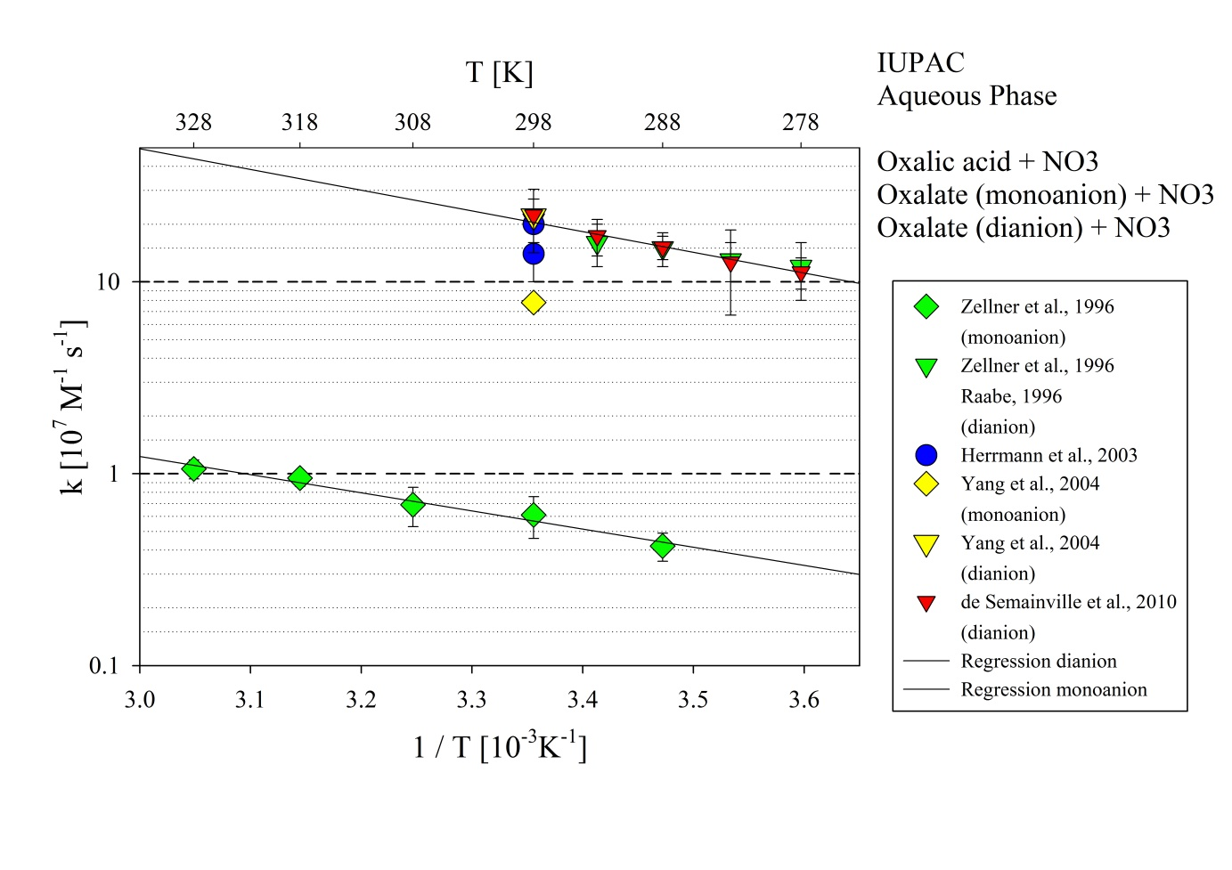
Figure 1: T-dependent rate constants for the reaction of oxalic acid with NO₃ in aqueous solution. Data from Zellner et al. (1996), Herrmann et al. (2003), Yang et al. (2004) and de Semainville et al. (2010). ); the regression for the dianion refers to data by Raabe (1996) and de Semainville et al. (2010); the regression for the monoanion refers to data from Zellner et al. (1996) and Raabe (1996); as the rate constant for oxalic acid by Yang et al. (2004) was the only available value, it was not considered in the Arrhenius plot.

