IUPAC Task Group on Atmospheric Chemical Kinetic Data Evaluation
– Data Sheet AQ_OH_8
Datasheets can be downloaded for personal use only and must not be retransmitted or disseminated either electronically or in hardcopy without explicit written permission.
The citation for this datasheet is: IUPAC Task Group on Atmospheric Chemical Kinetic Data Evaluation, http://iupac.pole-ether.fr.
This datasheet last evaluated: November 2019; last change in preferred values: March 2019
HO(aq) + (CH₃)₃COH (aq) | → | CH₂C(CH₃)₂OH (95.7%)
 |  | + (CH₃)₃CO (4.3%)
 |  | + H₂O (l)

(Product distributions taken from Buxton et al., 1988, originally determined by Asmus et al., 1973 via PR - UV/Vis)

Rate coefficient data

k/ l mol⁻¹ s⁻¹ | T/K | pH |  | I/ mol l⁻¹ | Reference |  |  | Technique/ Comments
Absolute Rate Coefficients
7.55 × 10⁸ | 294 | 7 | - |  |  | Gordon et al., 1977 | PR/UV-vis abs. (a)
6.2 × 10⁸ | 294 | slightly <pH 7 | - |  |  | Janata, 2002 | PR/UV-vis abs. (b)
6.2 × 10⁸ | 294 | slightly <pH 7 | - |  |  | Alam et al., 2003 | PR/UV-vis abs. (c)
Relative Rate Coefficients
4.2 × 10⁸ | 294 | 7 | - |  |  | Adams et al., 1965 | PR/UV-vis (d)
(7.3 ±0.7) × 10⁸ | 294 | 2.0 - 2.2 | - |  |  | Scholes et al., 1965 | CW-radiolysis /UV-vis (e)
4.8 × 10⁸ | 294 | 9 | - |  |  | Anbar et al., 1966 | CW-radiolysis /UV-vis (f)
7.3 × 10⁸ | 294 | 2 | - |  |  | Scholes and Willson, 1967 | CW-radiolysis /UV-vis (g)
5.7 × 10⁸ | 294 | - | - |  |  | Willson et al., 1971 | CW-radiolysis /UV-vis (h)
(5.9 ±0.4) × 10⁸ | 291 - 298 | 6.9 | - |  |  | Prütz and Vogel, 1976 | CW-radiolysis/ UV-vis (i1)
(6.6 ±1.2) × 10⁸ | 291 - 298 | 7 | - |  |  |  | CW-radiolysis/ UV-vis (i2)
(6.2 ±0.4) × 10⁸ | 294 | 6 | 0.3 × 10⁻³ |  |  | Wolfenden and Willson, 1982 | PR/UV-vis abs. (j)
6.2 × 10⁸ | 292 | - | 2-10 × 10⁻³ |  |  | Elliot and Simsons, 1984 | PR/UV-vis (k1)
3.2 × 10¹⁰ exp[(-1120 ±180) / T] | 292 - 352 | - | 2-10 × 10⁻³ |  |  |  | PR/UV-vis (k2)
4.8 × 10⁸ | 293 - 298 | 7.5 | - |  |  | Motohashi and Saito, 1993 | CW-irradiation /HPLC (l)
(4.8 ±0.6) × 10⁸ | 298 | - | 2 × 10⁻⁵ |  |  | Ervens et al., 2003 | LP-LPA (m)
9.20 × 10¹⁰ exp[(-890 ±120) / T] | 288 - 308 | - | 2 × 10⁻⁵
(8 ±2) × 10⁸ | 298 | 1-2 | - |  |  | Monod et al., 2005 | ASC/ GC-FID (n)

ΔG_{R}° (aq): Aqueous phase thermochemical data not available. As well, gas phase thermochemical data Η_{R}° (g) are not available.

Comments

- Direct observation of HO decay (280 nm); c(t-BuOH) = 0.5-2 M; the absolute rate coefficient has an error of ±10%.

- Direct observation of optical absorption of the alcohol radicals (260-290 nm); computer simulations were used to derive the rate coefficients; the simulations were accurate to 5%; N₂O saturated solutions

- Essentially the same article as (b)

- Product formation observed at 500 nm; reference reaction: HO + SCN⁻ with k(HO + SCN⁻) = 6.6 × 10⁹ M⁻¹s⁻¹; rate coefficients have been recalculated using the selected value for the reference reactions (1.10 × 10¹⁰ M⁻¹s⁻¹, Zhu et al., 2003); No exact value is given for the initial concentrations of the reactants (‘a few millimolar’) ; air or oxygen saturated solutions; as no exact temperature is given, for room temperature T = 294 K is assumed.

- Product formation observed at 264 nm; Reference reaction: HO + thymine; k(HO + thymine) = 3.1 × 10⁹ M⁻¹s⁻¹; rate coefficients have been recalculated using the selected value for the reference reaction (5.38 × 10⁹ M⁻¹s⁻¹); c(thymine) = 8-20 × 10⁻⁵ mol/l; air or oxygen saturated solutions; as no exact temperature is given, for room temperature T = 294 K is assumed.

- Reference reaction: HO + PNDA (p-nitrosodimethylaniline); the rate coefficient for the reference reaction was determined versus ethanol with k(HO + ethanol) = 1.88 × 10⁹ M⁻¹s⁻¹; no values given for initial concentrations; air saturated solutions; all experiments were repeated at least four times and the coefficient of variation was less than ±10%; as no exact temperature is given, for room temperature T = 294 K is assumed.

- Product formation observed at 264 nm; Reference reaction: HO + thymine; k(HO + thymine) = (4.3 ±1) × 10⁹ M⁻¹s⁻¹; rate coefficients have been recalculated using the selected value for reference reactions (5.38 × 10⁹ M⁻¹s⁻¹); c(thymine) = 8 × 10⁻⁵ – 2 × 10⁻⁴ mol/l ; The rate coefficient of the reference reaction was determined relative to benzene ; aerated solutions ; The absolute rate coefficients have an error of about ±25%; as no exact temperature is given, for room temperature T = 294 K is assumed.

- Product formation observed at 410 nm; Reference reaction: HO + [Fe(CN)₆]⁴⁻; k(HO + [Fe(CN)₆]⁴⁻) = (0.93 ±0.05) × 10¹⁰ M⁻¹s⁻¹; rate coefficients have been recalculated using the selected values for the reference reactions (1.03 × 10¹⁰ M⁻¹s⁻¹); c([Fe(CN)₆]⁴⁻) = 2 × 10⁻³ mol/l ; The reference values listed in table 1 were recalculated using k(HO + ethanol) = 1.85 × 10⁹ M⁻¹s⁻¹ ; in most reactions air was present or the solutions were saturated with N₂O; as no exact temperature is given, for room temperature T = 294 K is assumed.

- Products analysed by fluorescence measurements using Acriflavin ((i1) and (i2)) as RCL (Radiation Induced Chemiluminescence)-dye; (i1): buffered solution; (i2): unbuffered neutral solution; The absolute rate coefficients were obtained by comparing the slopes of the emission yields plotted against the concentrations of the different scavengers and using k(HO + methanol) = 8.5 × 10⁸ M⁻¹s⁻¹ as reference; recalculation was performed using the selected value for the reference reaction (9.22 × 10⁸ M⁻¹s⁻¹).

- Product formation observed at 415 nm; Reference reaction: HO + ABTS (2,2’-Azinobis-(3-ethylbenzthiazoline-6-sulphonate)); k(HO + ABTS) = 1.2 × 10¹⁰ M⁻¹s⁻¹; c(ABTS) = 1 × 10⁻⁴ mol/l ; N₂ and N₂O saturated solutions; the rate coefficient was recalculated using the selected value for the reference reaction (1.24 × 10¹⁰ M⁻¹s⁻¹); as no exact temperature is given, for room temperature T = 294 K is assumed.

- Product formation observed at 420 nm; Reference reaction: HO + Fe[(CN)₆]⁴⁻ with T-dependent rate coefficients given as k_{292K}(HO + Fe[(CN)₆]⁴⁻) = 10.1 × 10⁹ M⁻¹s⁻¹ ; k_{312K}(HO + Fe[(CN)₆]⁴⁻) = 14.4 × 10⁹ M⁻¹s⁻¹ ; k_{332K}(HO + Fe[(CN)₆]⁴⁻) = 19.9 × 10⁹ M⁻¹s⁻¹ ; k_{352K}(HO + Fe[(CN)₆]⁴⁻) = 24.6 × 10⁹ M⁻¹s⁻¹ ; c(K₄Fe[(CN)₆]) in the range of 2-10 × 10⁻³ mol/l ; N₂O saturated solutions. Arrhenius expression (k2) calculated using data from table 1, considering 10% error of activation energy; rate coefficients have been recalculated using the selected temperature dependence for the reference reaction rate coefficients (1.81 × 10¹² exp[(-1500/T)]).

- Products analysed by HPLC (abs. 240-300 nm) and fluorescence measurements (irradiation at 305 nm); Reference reaction: HO + benzoate; k(HO + benzoate) = 5.9 × 10⁹ M⁻¹s⁻¹ ; rate coefficients have been recalculated using the selected value for reference reactions (5.88 × 10⁹ M⁻¹s⁻¹); c(benzoate) = 2 × 10⁻⁴ mol/l; deviations of less than ±5% for the determined rate coefficients; N₂O saturated solutions

- Reference reaction: HO + SCN⁻; c(thiocyanate) = 2 × 10⁻⁵ mol/l, reference reaction rate coefficient given by: k(T) = 7.26 × 10¹² exp((-1900 ± 190) / T) M⁻¹s⁻¹ by Chin and Wine (1992); rate coefficients have been recalculated using the selected T-dependent rate coefficients for the reference reaction by Zhu et al., 2003.

- Radicals generated by Photo-Fenton-reaction in a bulk reactor (an ‘aqueous phase smog chamber’ or ‘ASC’), products analysed by GC-FID; Reference reaction: HO + 2-propanol; k(HO + 2-propanol) = 1.9 × 10⁹ M⁻¹s⁻¹; recalculation of the rate coefficient was performed using the selected value for the reference reaction (2.27 × 10⁹ M⁻¹s⁻¹).

Preferred Values

Parameter | Value | T/K
k /L mol⁻¹ s⁻¹ | 6.29 × 10⁸ | 298
k /L mol⁻¹ s⁻¹ | 9.15 × 10¹⁰ exp[-(1500)/T] | 288 - 352

Reliability
Δ log k | ±0.15 | 298
Δ E_{A}/R | ±310 | 288 – 352

Comments on Preferred Values

The rate constants available for room temperature show scatter within about a factor of two ranging from 4.2 to 7.6 × 10⁸ M⁻¹s⁻¹ (Adams et al., 1965 and Gordon et al., 1977). Considering the two available temperature dependent determinations by Elliot and Simsons (1984) and Ervens et al. (2003), the regression is leading to a mean of 6.3 × 10⁸ M⁻¹s⁻¹, which is confirmed by other determinations within error limits. The uncertainty is estimated to be ±33% or Δ log k = 0.15.

References

Adams, G.E., Boag, J.W., Currant, J. and Michael, B.D., Pulse Radiolysis, Ebert, M., Keene, J.P., Swallow, A.J. and Baxendale, J.H. (eds.): Academic Press, New York, 131-143, 1965.

Alam, M. S., Rao, B. S. M. and Janata, E.: Radiat. Phys. Chem., 67(6), 723-728, 2003.

Anbar, M., Meyerstein, D. and Neta, P.: J. Chem. Soc. B, 742-747, 1966.

Asmus, K. D., Möckel, H. and Henglein, A.: J. Phys. Chem., 77(10), 1218-1221, 1973.

Buxton, G. V., Greenstock, C. L., Helman, W. P. and Ross, A. B.: J. Phys. Chem Ref. Data, 17(2), 513-886, 1988.

Chin, M. and Wine, P. H: J. Photochem. Photobiol., A, 69(1), 17-25, 1992.

Elliot, A. J. and Simsons, A. S.: Radiat. Phys. Chem., 24(2), 229-231, 1984.

Ervens, B., Gligorovski, S. and Herrmann, H.: Phys. Chem. Chem. Phys., 5(9), 1811-1824, 2003.

Gordon, S., Schmidt, K. H. and Hart, E. J.: J. Phys. Chem., 81(2), 104-109, 1977.

Janata, E.: J. Chem. Sci., 114(6), 731-737, 2002.

Monod, A., Poulain, L., Grubert, S., Voisin, D. and Wortham, H.: Atmos. Environ., 39(40), 7667-7688, 2005.
Motohashi, N. and Saito, Y.: Chem. Pharm Bull., 41(10), 1842-1845, 1993.

Pruetz, W. A. and Vogel, S.: Z. Naturforsch., B: Chem. Sci., 31(11), 1501-1510, 1976.

Scholes, G., Shaw, P. and Willson, R.L.: Pulse Radiolysis, academic press, 61, 1965

Scholes, G. and Willson, R. L.: Trans. Far. Soc., 63, 2983-2993, 1967.

Willson, R. L., Greenstock, C. L., Adams, G. E., Wageman, R. and Dorfman, L. M.: Int. J. Radiat. Phys. Chem., 3(3), 211-220, 1971.

Wolfenden, B. S. and Willson, R. L.: J. Chem. Soc. Perkin Trans. II, 7, 805-812, 1982.
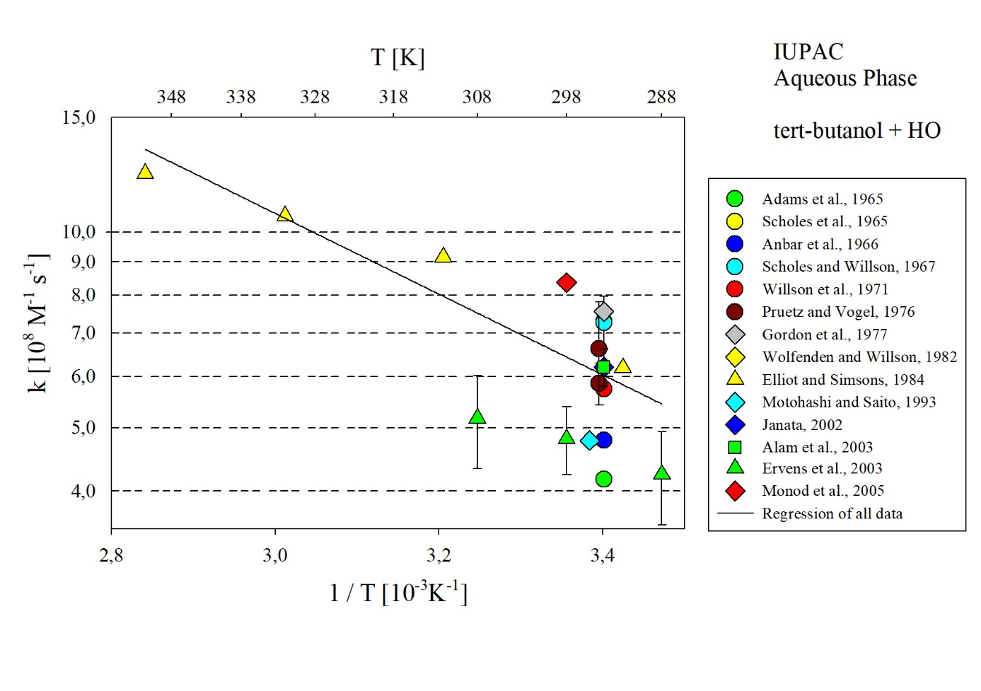
T-dependent rate coefficients for the reaction of tert-butanol with HO in aqueous solution. All data sets shown in the Figure were considered for regression.

