IUPAC Task Group on Atmospheric Chemical Kinetic Data Evaluation
– Data Sheet AQ_OH_81
Datasheets can be downloaded for personal use only and must not be retransmitted or disseminated either electronically or in hardcopy without explicit written permission.
The citation for this datasheet is: IUPAC Task Group on Atmospheric Chemical Kinetic Data Evaluation, http://iupac.pole-ether.fr.
This datasheet last evaluated: November 2019; last change in preferred values: June 2019

H₂O + CH₃CH₂COCH₃ (aq) → CH₃CH₂C(OH)₂CH₃ (aq) (1)

HO (aq) + CH₃CH₂COCH₃ (aq) → CH₃CHCOCH₃ (aq) + H₂O (2)

(product formation taken from Mezyk, 1994)

Rate coefficient data

k/ L mol⁻¹ s⁻¹ | T/K | pH | I/ mol L⁻¹ | Reference | Technique/ Comments
Relative Rate Coefficients
9.0 × 10⁸ | 294 | 6-7 | - | Adams et al., 1965 | PR / UV-Vis (a)
(7.17 ±0.08) × 10⁸ | 297.4 | 5.2 | - | Mezyk, 1994 | PR / UV-Vis (b)
4.77 × 10¹⁰ exp [- (1250 ±40)/T] | 275 - 340 | 5.2 | - |  | PR / UV-Vis (b)
(1.4 ±0.7) × 10⁹ | 298 | - | - | Gligorovski and Herrmann, 2004 | LP-LPA (c)
3.0 × 10¹¹ exp [- (1660 ±380)/T] | 278 - 348 | - | - |  | LP-LPA (c)
(8.1 ±0.8) × 10⁸ | 298 | 2 | - | Monod et al., 2005 | Dark Fenton / GC-FID (d)
1.55 × 10¹⁰ exp [- (900 ±240)/T] | 276 - 339 | 2 | - |  | Dark Fenton / GC-FID (d1)

The equilibrium constant for the hydration (1) has been estimated to be K_{298 K} = 3.8 × 10⁻³ by Raventos-Duran et al. (2010).

ΔG_{R}° (aq): Aqueous phase thermochemical data not available. As well, gas phase thermochemical data Η_{R}° (g) are not available.

Comments

(a) Reference reaction: HO + SCN⁻ with k(HO + SCN⁻) = 6.6 × 10⁹ M⁻¹s⁻¹; recalculation has been performed using the selected value for the reference reaction (1.10 × 10¹⁰ M⁻¹s⁻¹); no exact value is given for the initial concentrations of the reactants; as no exact temperature is given, for room temperature T = 294 K is assumed.

(b) Reference reaction: HO + SCN⁻ with k(HO + SCN⁻) = 1.22 × 10¹⁰ M⁻¹s⁻¹ according to Chin and Wine (1992); recalculation has been performed using the selected T dependence for the reference reaction by Zhu et al. (2003); experiments were performed in deoxygenated N₂O / N₂ saturated solutions

(c) Radicals generated by excimer laser flash photolysis of H₂O₂ at 248 nm; reactions were investigated by laser flash photolysis long path absorption relative to k(HO + SCN⁻) = 1.24 × 10¹⁰ M⁻¹ s⁻¹ as determined by Chin and Wine (1992); recalculation has been performed using the selected T dependence for the reference reaction by Zhu et al. (2003).

(d) Radicals generated by dark Fenton reaction, products analysed by GC-FID; Reference reactions:·HO + ethanol with ln k(T) = (24.2 ±0.4)-(830 ±140)/T (from data of Monod, 2005 and Ervens et al., 2003); HO + 1-propanol with ln k(T) = (24.5 ±0.6)-(780 ±200)/T (from data of Monod, 2005 and Ervans et al., 2003); HO + formaldehyde; k(T) = exp[-1020±90 (1/T)] (Chin and Wine, 1994); For the Fenton-reaction, the initial concentrations of reactants were in the order of 1 × 10⁻³ M; Arrhenius expression (d1) is calculated from experimental data of Monod (2005), but given as: ln k(T) = (26.2±1.0) – [(1600±300)]/T in their work, resulting from the combined data of Monod (2005), Adams et al. (1965), Mezyk et al. (1994) and Gligorowski et al. (2009); no recalculation has been done on the T-dependent rate coefficients, as four out of seven determinations are given as mean values referring to two different reference reactions.

Preferred Values

Parameter | Value | T/K
k / L mol⁻¹ s⁻¹ | 9.77 × 10⁸ | 298
k / L mol⁻¹ s⁻¹ | 2.35 × 10¹¹ exp [-(1630)/T] | 274 - 348

Reliability
Δ log k | ±0.24 | 298
Δ E_{A}/R | ±350 | 274 - 348

Comments on Preferred Values

Since the recommendation of Buxton et al. in 1988 with k = 9.0 × 10⁸ M⁻¹s⁻¹, three temperature dependent determinations became available. As the publication by Monod (2005) does not provide information about the individually determined rate coefficients, a possible reevaluation of these values could not be performed. Therefore, this determination was not taken into consideration for the final regression. While the temperature dependent studies by Mezyk (1994) and Monod et al. (2005) are in good agreement with each other, the results of Gligorovski and Herrmann (2004) indicate a higher rate constant for the reaction. Therefore, the preferred room temperature rate coefficient is suggested to be slightly higher than in the publications mentioned before with an estimated uncertainty of ±50% or Δ log k = ±0.24.

References

Adams, G.E.; Boag, J.W.; Currant, J.; Michael, B.D.: Pulse Radiolysis, Ebert, M.; Keene, J.P.; Swallow, A.J.; Baxendale, J.H. (eds.), Academic Press, New York, p.131-43, 1965.

Buxton, G. V., Greenstock, C. L., Helman, W. P., Ross, A. B.: J. Phys. Chem. Ref. Data, Vol. 12 (2), 513 – 886, 1988.

Chin, M., and Wine, P. H: J. Photochem. Photobiol., A, 69(1), 17-25, 1992.

Gligorovski, S. and Herrmann, H.: Phys. Chem. Chem. Phys., 6(16), 4118-4126, 2004.

Mezyk, S. P.: Can. J. Chem., 72(4), 1116-1119, 1994.

Monod, A., Poulain, L., Grubert, S., Voisin, D. and Wortham, H.: Atmos. Env., 39(40), 7667-7688, 2005.

Raventos-Duran, T., Camredon, M., Valorso, R., Mouchel-Vallon, C. and Aumont, B.: Atmos. Chem. Phys., 10(16), 7643-7654, 2010.

Zhu, L., Nicovich, J. M. and Wine, P. H.: Aquat. Sci., 65(4), 425-435, 2003.

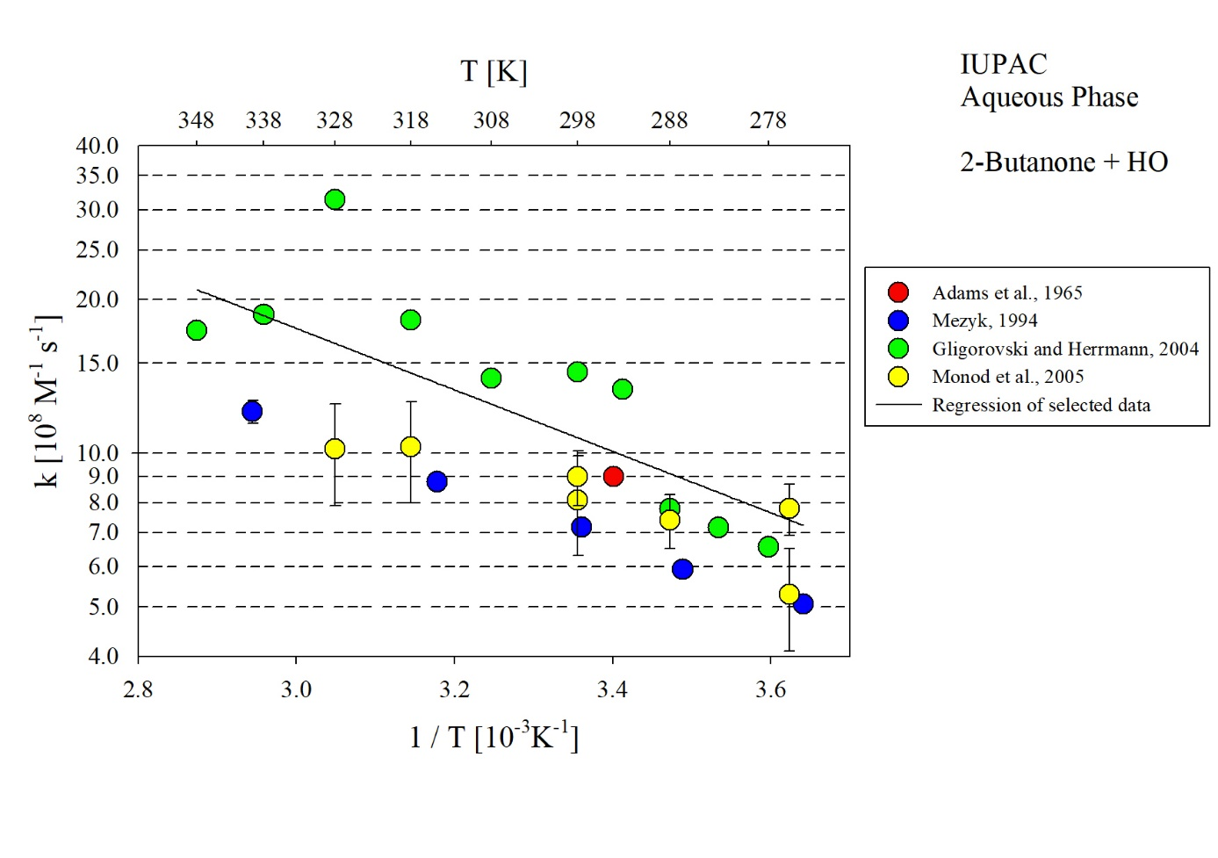
T-dependent rate constants for the reaction of 2-Butanone with HO in aqueous solution. Data from Adams et al. (1965), Mezyk (1994) and Gligorovski and Herrmann (2004) were used for the regression.

