IUPAC Task Group on Atmospheric Chemical Kinetic Data Evaluation
– Data Sheet AQ_OH_6
Datasheets can be downloaded for personal use only and must not be retransmitted or disseminated either electronically or in hardcopy without explicit written permission.
The citation for this datasheet is: IUPAC Task Group on Atmospheric Chemical Kinetic Data Evaluation, http://iupac.pole-ether.fr.
This datasheet last evaluated: June 2019; last change in preferred values: March 2019
HO (aq) + CH₃CH₂CH(OH)CH₃ (aq) → Products

Rate coefficient data

k/ l mol⁻¹ s⁻¹ | T/K | pH |  | I/ mol l⁻¹ | Reference |  | Technique/ Comments
Absolute Rate Coefficients
3.5 ± 0.4 × 10⁹  4.7 ± 0.8 × 10⁹  6.3 ± 0.5 × 10⁹  6.8 ± 1.4 × 10⁹  6.3 ± 1.2 × 10⁹  7.3 ± 2.5 × 10⁹  5.4 ± 3.0 × 10⁹ | 298 | 5.8 | 0  0.5 (0.46)  1.0 (0.85)  1.5 (1.21)  2.0 (1.53)  2.5 (1.83)  3.0 (2.11) |  |  | Hesper, 2003 | LP/LPA (a1)
7.4 × 10¹⁰ exp[-(910 ± 330)K/T] | 288-328 | - | - |  |  |  | LP/LPA (a2)
Relative Rate Coefficients
3.1 × 10⁹ | 294 | 7 | - |  |  | Adams et al.,  1965 | PR/UV-vis (b)
2.4 × 10⁹ | 294 | 9 | - |  |  | Anbar and Neta,  1966 | CW-radiolysis /UV-vis (c)
2.8 × 10⁹ | 294 | 2 | - |  |  | Scholes and Willson,  1967 | CW-radiolysis /UV-vis (d)

ΔG_{R}° (aq): Aqueous phase thermochemical data not available. As well, gas phase thermochemical data Η_{R}° (g) are not available.

Comments

- Product formation observed at 260 nm; direct observation of optical absorption of the peroxyl-radicals formed by the reaction between HO, 2-Butanol and O₂; oxygen saturated solutions (a1): determination of ion strength influence; NaClO₄ was used to adjust the ion strength; the numbers given in parenthesis refer to the calculated effective ion strength; (a2): determination of the temperature influence from 288-328 K; the Arrhenius expression was calculated using these values. Reviewed by Herrmann (2003).

- Product formation observed at 500 nm; reference reaction: HO + SCN⁻; k(HO + SCN⁻) = 6.6 × 10⁹ M⁻¹s⁻¹; the rate coefficient has been recalculated using the selected value for the reference reaction (1.10 × 10¹⁰ M⁻¹s⁻¹, Zhu et al., 2003); No exact value is given for the initial concentrations of the reactants (‘a few millimolar’); air or oxygen saturated solutions; as no exact temperature is given, for room temperature T = 294 K is assumed.

- Reference reaction: HO + PNDA (p-nitrosodimethylaniline); rate coefficient for the reference reaction was determined versus ethanol with k(HO + ethanol) = 1.88 × 10⁹ M⁻¹s⁻¹; no values given for initial concentrations; air saturated solutions; all experiments were repeated at least four times and the coefficient of variation was less than ± 10%; as no exact temperature is given, for room temperature T = 294 K is assumed.

- Product formation observed at 264 nm; Reference reaction: HO + thymine; k(HO + thymine) = (4.3 ±1) × 10⁹ M⁻¹s⁻¹; the rate coefficient has been recalculated using the selected value for the reference reaction (5.38 × 10⁹ M⁻¹s⁻¹); c(thymine) = 8 × 10⁻⁵ - 2 × 10⁻⁴ mol/l ; The rate coefficient of the reference reaction was determined relative to benzene ; aerated solutions ; The absolute rate coefficients in table 3 have an error of about ±25%; as no exact temperature is given, for room temperature T = 294 K is assumed.

Preferred Values

Parameter | Value | T/K
k / l mol⁻¹ s⁻¹ | 3.19 × 10⁹ | 298
k / l mol⁻¹ s⁻¹ | 2.53 × 10¹¹ exp[-(1300) / T] | 288 – 328

Reliability
Δ log k | ± 0.04 | 298
Δ E_{A}/R | ± 330 | 288 – 328

Comments on Preferred Values

The recommended value is a combination of the more recent determination by Hesper et al. (2003) and the three room temperature rate coefficients of Adams et al. (1965), Anbar and Neta (1966) and Scholes and Willson (1967). The error of the room temperature rate coefficient is estimated to be Δ log k = ±0.04 or ±10%. The data by Hesper essentially confirm the older value by an independent measurement.

References

Adams, G.E., Boag, J.W., Currant, J. and Michael, B.D., Pulse Radiolysis, Ebert, M., Keene, J.P., Swallow, A.J. and Baxendale, J.H. (eds.): Academic Press, New York, 131-143, 1965.

Anbar, M., Meyerstein, D. and Neta, P.: J. Chem. Soc. B, 742-747, 1966.

Herrmann, H.: Chem. Rev., 103(12), 4691-4716, 2003.

Hesper, J.: Ph.D. Dissertation, University of Leipzig, Leipzig, Germany, 2003.

Scholes, G. and Willson, R. L.: Trans. Faraday Soc., 63, 2983-2993, 1967.

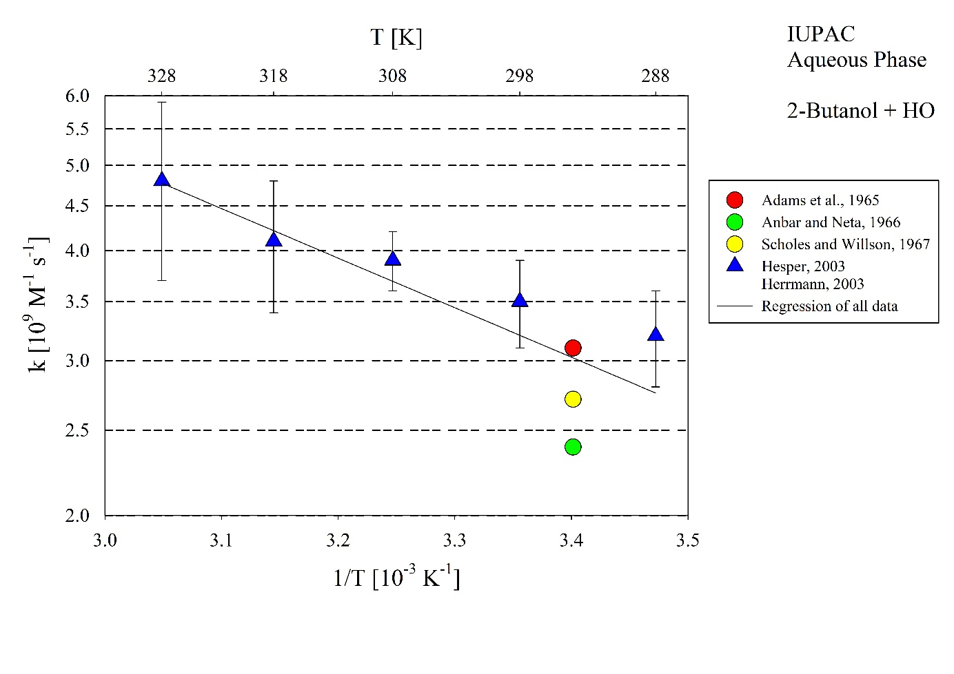T-dependent rate coefficients for the reaction of 2-Butanol with HO radicals in aqueous solution. All data has been used for regression.

