IUPAC Task Group on Atmospheric Chemical Kinetic Data Evaluation
– Data Sheet AQ_OH_60
Datasheets can be downloaded for personal use only and must not be retransmitted or disseminated either electronically or in hardcopy without explicit written permission.
The citation for this datasheet is: IUPAC Task Group on Atmospheric Chemical Kinetic Data Evaluation, http://iupac.pole-ether.fr.
This datasheet last evaluated: November 2019; last change in preferred values: June 2019

HCHO(aq) + H₂O → CH₂(OH)₂(aq) (1)
HO(aq) + CH₂(OH)₂(aq) → CH(OH)₂ + H₂O (2)

(product distribution given by Chin and Wine (1994))

Rate coefficient data

k/ L mol⁻¹ s⁻¹ | T/K | pH | I/ mol L⁻¹ | Reference | Technique/ Comments
Relative Rate Coefficients
1.3× 10⁹ | 291 | 1 | - | Merz and Waters, 1949 | Fenton-mechanism (a)
1.3× 10⁹ | 294 | - | - | Hart et al., 1964 | Steady-state method (b)
(7.7 ±1.2) × 10⁸ | 297 | 1.5 – 5.7 | - | Chin and Wine, 1994 | LFP-LPA (d1)
2.53 × 10¹⁰ exp[-(1040 ± 70)/T] | 279 – 319 | 1.5 – 5.7 | - |  | LFP-LPA (d2)

The equilibrium constant for the hydration (1) is recommended as K_{298 K} = 2000 by Doussin and Monod (2013).

ΔG_{R}° (aq): Aqueous phase thermochemical data not available. As well, gas phase thermochemical data Η_{R}° (g) are not available.

Comments

(a) Merz and Waters are giving a relative rate constant k = 3.0, relative to the reference reaction (HO + Fe²⁺) without stating a specific rate constant; product analysis by colorimetric determination; for the recalculation of this value, the selected rate coefficient for the reference reaction k(HO + Fe²⁺) = 4.3 × 10⁸ M⁻¹s⁻¹ has been used.

(b) The rate constant has been determined from the plotted data, as there was no value given in the paper (Figure 1; Hart et al., 1964); reference reaction: HO + H₂O₂, with k(HO + H₂O₂) = 4.5 × 10⁷ M⁻¹s⁻¹ as determined by Schwarz (1962); rate coefficients have been recalculated using the selected values for the reference reactions (2.97 × 10⁷ M⁻¹s⁻¹). It has been stated by Hart et al., that due to the lower reactivity, nearly exclusively methanediol is expected to be part of the reaction, rather than molecular formaldehyde; as no exact temperature is given, T = 294 K is assumed for room temperature.

(c) Reference reaction: HO + SCN⁻ with temperature-dependent rate coefficient given as ln(k) = 28.7665 – (1655 / T) M⁻¹ s⁻¹; c(SCN⁻) = (0.5 – 5) × 10⁻⁵ M; The error includes an estimated ±10% uncertainty in the H₂C(OH)₂ concentration (c1); k(T) data are given relative to the reference reaction (Table 1; Chin and Wine, 1994), errors are 1σ; k₂₉₇(HO + SCN⁻) = 1.18 × 10¹⁰ M⁻¹s⁻¹ (calculated from given data) (c2); rate coefficients have been recalculated using the selected values for the T dependent reference reaction (Zhu et al., 2003).

Preferred Values

Parameter | Value | T/K
k / L mol⁻¹ s⁻¹ | 1.12 × 10⁹ | 298

Reliability
Δ log k | ±0.3 | 298

Comments on Preferred Values

For the room temperature rate constant, the mean value of the data by Merz and Waters (1949), Hart et al. (1964) and Chin and Wine (1994) is suggested. The estimated uncertainty for that rate ceofficient is ±50% or Δ log k = 0.3. While the two determinations at room temperature agree well with each other after the recalculation, the discrepancy with the temperature dependent data is significant. A reliable Arrhenius expression is rather not to be determined and recommended.

References

Chin, M. and Wine, P. H.: Aquat. Surf. Photochem., 85-96, 1994.

Doussin, J. F. and Monod, A.: Atmos. Chem. Phys., 13(23), 11625-11641, 2013.

Hart, E. J., Thomas, J. K. and Gordon, S.: Radiat. Res. Suppl., 4, 74-88, 1964.

Merz, J. H. and Waters, W. A.: Faraday Soc., 2(1), 179-191, 1947.

Schwarz, H. A.: J. Phys. Chem., 66(2), 255-262, 1962.

Zhu, L., Nicovich, J. M. and Wine, P. H.: Aquat. Sci., 65(4), 425-435, 2003.

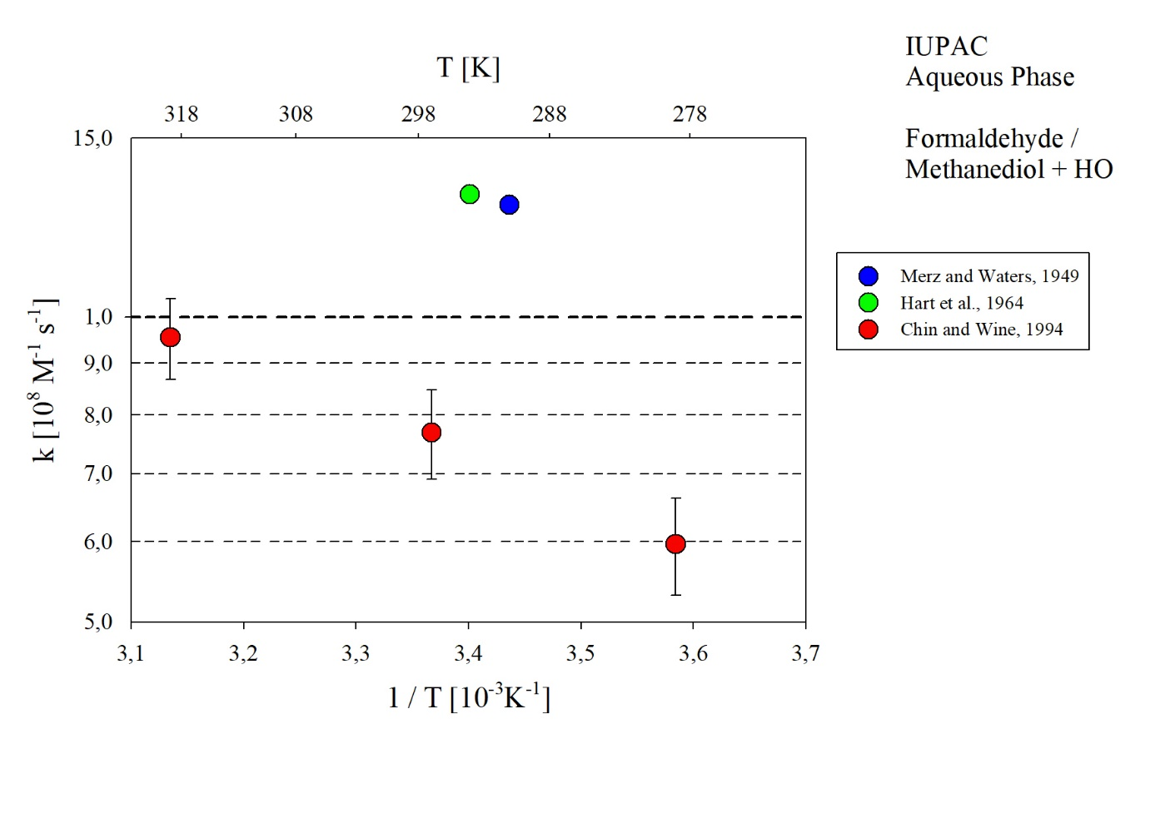
T-dependent rate coefficients for the reaction of Formaldehyde / Methanediol with HO in aqueous solution. All data given in the plot have been considered for evaluation.

