IUPAC Task Group on Atmospheric Chemical Kinetic Data Evaluation
– Data Sheet AQ_OH_47
Datasheets can be downloaded for personal use only and must not be retransmitted or disseminated either electronically or in hardcopy without explicit written permission.
The citation for this datasheet is: IUPAC Task Group on Atmospheric Chemical Kinetic Data Evaluation, http://iupac.pole-ether.fr.
This datasheet last evaluated: November 2019; last change in preferred values: June 2019

HO (aq) + HO(CH₂)₅OH(aq) → products

Rate coefficient data

k/ L mol⁻¹ s⁻¹ | T/K | pH | I/ mol L⁻¹ | Reference | Technique/ Comments
Relative Rate Coefficients
3.6 × 10⁹ | 294 | 9 | - | Anbar et al., 1966 | PR / UV-Vis (a)
(4.2 ±0.7) × 10⁹ | 298 | 7 | - | Hoffmann et al., 2009 | LF-LPA (b)
1.38 × 10¹¹ exp[-(1000 ±90)/T] | 278 - 318 | 7 | - |  | LF-LPA (b1)

ΔG_{R}° (aq): Aqueous phase thermochemical data not available. As well, gas phase thermochemical data Η_{R}° (g) are not available.

Comments

(a) Reference reaction: HO + PNDA (p-nitrosodimethylaniline); reference rate constant was determined versus ethanol with k(HO + ethanol) = 1.10 × 10⁹ M⁻¹s⁻¹; recalculation of the rate coefficient was performed, using the selected value for the reference reaction (1.88 × 10⁹ M⁻¹s⁻¹); no values given for initial concentrations; air saturated solutions; all experiments were repeated at least four times and the coefficient of variation was less than ± 10%; as no temperature is given in their publication, for room temperature of T = 294 K is assumed.

(b) Radicals generated by laser flash photolysis of H₂O₂ (c(H₂O₂) = 1 × 10⁻⁴ M) at 248 nm (LF-LPA); Reference reaction: HO + SCN⁻ with k(HO + SCN⁻) = 1.24 × 10¹⁰ M⁻¹ s⁻¹ as reported by Chin and Wine (1992); the selected temperature dependence for the reference reaction by Zhu et al. (2003) was used for recalculation; c(KSCN) = 1.59 × 10⁻⁵ M. Arrhenius expression (b1) was calculated using the recalculated experimental data from Hoffmann et al. (2009).

Preferred Values

Parameter | Value | T/K
k / L mol⁻¹ s⁻¹ | 4.10 × 10⁹ | 298
k / L mol⁻¹ s⁻¹ | 1.47 × 10¹¹ exp[-(1100)/T] | 278 – 318

Reliability
Δ log k | ±0.15 | 298
Δ E_{A}/R | ±150 | 278 – 318

Comments on Preferred Values

The available rate coefficient determined by Anbar et al. (1966) has been combined with the temperature dependent determination by Hoffmann et al. (2009). As the data agree well with each other within error limits, the result is the mean of them. The formerly recommended rate coefficient by Buxton et al. in 1988 (3.6 × 10¹⁰ M⁻¹ s⁻¹) and Monod and Doussin in 2008 (3.81 × 10¹⁰ M⁻¹ s⁻¹) are both slightly lower than the present recommendation after adjustment to the new reference rate constant by Zhou et al. (2003), but they still agree with it within error limits. The relative error of the recommended room temperature rate coefficient is estimated to be ±33% or Δ log k = ±0.15.

References

Anbar, M., Meyerstein, D. and Neta, P.: J. Chem. Soc. B, 742-747, 1966.

Buxton, G. V., Greenstock, C. L., Helman, W. P. and Ross, A. B.: J. Phys. Chem. Ref. Data, 12(2), 513 – 886, 1988.

Hoffmann, D., Weigert, B., Barzaghi, P. and Herrmann, H.: Phys. Chem. Chem. Phys., 11, 9351-9363, 2009.

Kraljić, I. and Trumbore, C. N.: J. Am. Chem. Soc. 87(12), 2547-2550, 1965.

Monod, A. and Doussin, J. F.: Atmos. Environ., 42, 7611–7622, 2008.

Zhu, L., Nicovich, J. M. and Wine, P. H.: Aquat. Sci., 65(4), 425-435, 2003.

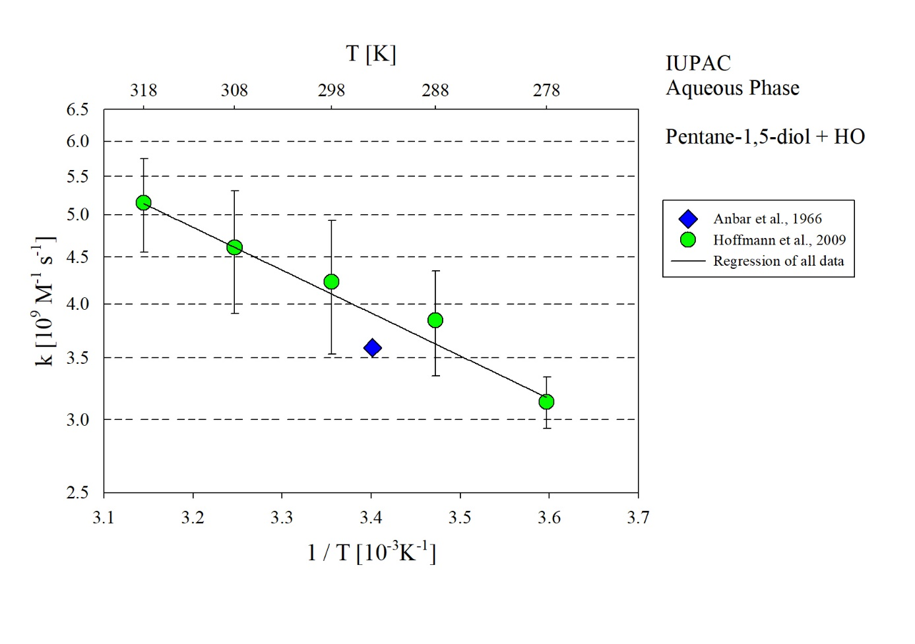
T-dependent rate constants for the reaction of pentane-1,5-diol with HO in aqueous solution. All available data have been used for regression.

