IUPAC Task Group on Atmospheric Chemical Kinetic Data Evaluation
– Data Sheet AQ_OH_42
Datasheets can be downloaded for personal use only and must not be retransmitted or disseminated either electronically or in hardcopy without explicit written permission.
The citation for this datasheet is: IUPAC Task Group on Atmospheric Chemical Kinetic Data Evaluation, http://iupac.pole-ether.fr.
This datasheet last evaluated: November 2019; last change in preferred values: June 2019

HO (aq) + CH₃CHOHCH₂OH(aq) → products

Rate coefficient data

k/ L mol⁻¹ s⁻¹ | T/K | pH | I/ mol L⁻¹ | Reference | Technique/ Comments
Relative Rate Coefficients
1.68 × 10⁹ | 294 | 7 | - | Adams et al., 1965 | PR / UV-Vis (a)
1.7 × 10⁹ | 294 | 9 | - | Anbar et al., 1966 | PR / UV-Vis (b)
(1.6 ±0.3) × 10⁹ | 298 | 7 | - | Hoffmann et al., 2009 | LFP-LPA (c)
9.37 × 10¹⁰ exp[-(1200 ± 340)/T] | 288 - 328 | 7 | - |  | LFP-LPA (c1)

ΔG_{R}° (aq): Aqueous phase thermochemical data not available. As well, gas phase thermochemical data Η_{R}° (g) are not available.

Comments

(a) Reference reaction: HO + SCN⁻ with k(HO + SCN⁻) = 6.6 × 10⁹ M⁻¹s⁻¹; rate constnats have been recalculated using the selected values for the reference reactions (1.10 × 10¹⁰ M⁻¹s⁻¹); No exact value is given for the initial concentrations of the reactants; pH is given as natural; as no exact temperature is given, T = 294 K is assumed for room temperature.

(b) Reference reaction: HO + PNDA (p-nitrosodimethylaniline); reference rate constant was determined versus ethanol with k(HO + ethanol) = 1.10 × 10⁹ M⁻¹s⁻¹; recalculation of the rate coefficient was performed using the selected value for the reference reaction (1.88 × 10⁹ M⁻¹s⁻¹); no values given for initial concentrations; air saturated solutions; all experiments were repeated at least four times and the coefficient of variation was less than ± 10%; as no exact temperature is given, T = 294 K is assumed for room temperature.

(c) Radicals generated by laser flash photolysis of H₂O₂ (c(H₂O₂) = 1 × 10⁻⁴ M) at 248 nm (LF-LPA); Reference reaction: HO + SCN⁻ with k(HO + SCN⁻) = 1.24 × 10¹⁰ M⁻¹ s⁻¹ as reported by Chin and Wine (1992); rate constants have been recalculated using the selected values for the temperature dependent reference reaction by Zhu et al., 2003; c(KSCN) = 1.59 × 10⁻⁵ M. Arrhenius expression (c1) was calculated using the recalculated experimental data from Hoffmann et al. (2009).

Preferred Values

Parameter | Value | T/K
k / L mol⁻¹ s⁻¹ | 1.75 × 10⁹ | 298
k / L mol⁻¹ s⁻¹ | 8.32× 10¹⁰ exp[-(1200)/T] | 288 – 328

Reliability
Δ log k | ±0.15 | 298
Δ E_{A}/R | ±240 | 288 - 328

Comments on Preferred Values

The room temperature rate coefficients determined by Adams et al. (1965), Anbar et al. (1966) and the T-dependent data by Hoffmann et al. (2009) have been used for regression. As the room temperature rate coefficients contribute perfectly to the Arrhenius expression of Hoffmann et al., the result is the mean of them, with an estimated uncertainty of Δ log k = ±0.15 or ±33%.

References

Adams, G.E.; Boag, J.W.; Currant, J. and Michael, B.D., Pulse Radiolysis, Ebert, M.; Keene, J.P.; Swallow, A.J. and Baxendale, J.H. (eds.): Academic Press, New York, p.131-143, 1965.

Anbar, M., Meyerstein, D. and Neta, P.: J. Chem. Soc. B, 742-747, 1966.

Hoffmann, D., Weigert, B., Barzaghi, P. and Herrmann, H.: Phys. Chem. Chem. Phys., 11, 9351-9363, 2009

Kraljić, I. and Trumbore, C. N.: J. Am. Chem. Soc. 87(12), 2547-2550, 1965.

Monod, A. and Doussin, J. F.: Atmos. Environ., 42, 7611-7622, 2008.

Zhu, L., Nicovich, J. M. and Wine, P. H.: Aquat. Sci., 65(4), 425-435, 2003.
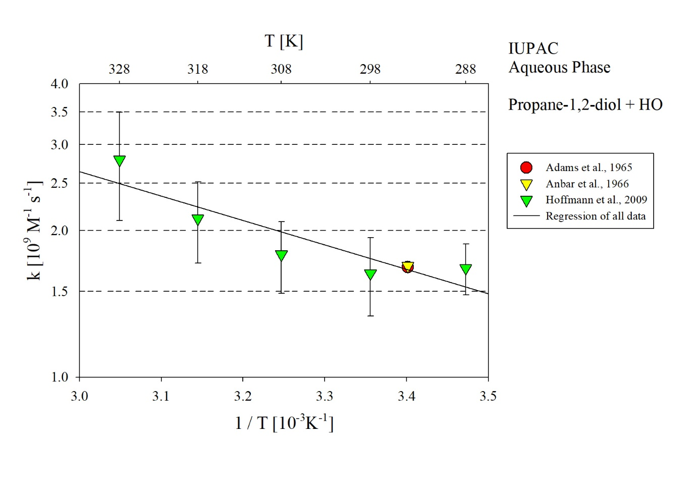
T-dependent rate constants for the reaction of propane-1,2-diol with HO in aqueous solution. All available data has been used for regression.

