IUPAC Task Group on Atmospheric Chemical Kinetic Data Evaluation
– Data Sheet AQ_OH_3
Datasheets can be downloaded for personal use only and must not be retransmitted or disseminated either electronically or in hardcopy without explicit written permission.
The citation for this datasheet is: IUPAC Task Group on Atmospheric Chemical Kinetic Data Evaluation, http://iupac.pole-ether.fr.
This datasheet last evaluated: June 2019; last change in preferred values: March 2019
HO (aq) + CH₃CH₂CH₂OH (aq) | → | CH₃CH₂CHOH (aq) (53.4%)
 |  | + CH₂CH₂CH₂OH (aq)
+ CH₃CHCH₂OH (aq) (46%)
+ H₂O (l)

(Product distributions taken from Buxton et al., 1988, originally determined by Asmus et al., 1973 via PR - UV/Vis)

Rate coefficient data

k/ l mol⁻¹ s⁻¹ | T/K |  | pH |  | I/ mol l⁻¹ |  | Reference | Technique/ Comments
Relative Rate Coefficients
2.5 × 10⁹ |  | 294 |  | 7 |  | - | Adams et al. 1965 | PR/UV-vis (a1)
2.79 × 10⁹ |  | 294 |  | 10.7 |  | - |  | PR/UV-vis (a2)
2.5 × 10⁹ |  | 294 |  | 7 |  | - | Adams et al., 1965 | PR/UV-vis (b1)
2.8 × 10⁹ |  | 294 |  | 10.7 |  | - |  | PR/UV-vis (b2)
2.82 × 10⁹ |  | 294 |  | 9 |  | - | Anbar et al., 1966 | CW / UV-vis (c)
3.3 × 10⁹ |  | 294 |  | 2 |  | - | Scholes and Willson, 1967 | CW /UV-vis (d1)
3.0 × 10⁹ |  | 294 |  | 5 |  | - |  | CW /UV-vis (d2)
3.0 × 10⁹ |  | 294 |  | - |  | - | Willson et al., 1971 | PR/UV-vis (e)
(3.1 ±0.2) × 10⁹ |  | 298 |  | 6 |  | 2 × 10⁻⁵ | Ervens et al., 2003 | LP-LPA (f)
2.71 × 10¹⁰ exp[(-600 ±240) / T] |  | 288 - 328 |  | 6 |  | 2 × 10⁻⁵
(3.8 ±0.7) × 10⁹ |  | 298 |  | 1 - 2 |  | - | Monod et al., 2005 | ASC / GC-FID (g1)
2.85 × 10¹¹ exp [- (1250 ± 220)/T] |  | 276 - 339 |  | 1 - 2 |  | - |  | ASC / GC-FID (g2)

ΔG_{R}° (aq): Aqueous phase thermochemical data not available. Gas phase thermochemical data Η_{R}° (g) are also not available (cf. gas phase data sheet HOx_VOC25)

Comments

- Reference systems HO + SCN⁻ with k(HO + SCN⁻) = 6.6 × 10⁹ M⁻¹s⁻¹ [1.10 × 10¹⁰M⁻¹s⁻¹ (Zhu et al., 2003)] (a1); HO + CO₃²⁻ with k(HO + CO₃²⁻) = 2.0 × 10⁸ M⁻¹s⁻¹ [3.77 × 10⁸M⁻¹s⁻¹](a2); rate constants have been recalculated using the selected values for the reference reactions, given in brackets; no exact value is given for the initial concentrations of the reactants (‘a few millimolar’); as no exact temperature is given, for room temperature T = 294 K is assumed.

- Reference systems: HO + SCN⁻ with k(HO + SCN⁻) = 6.6 × 10⁹ M⁻¹s⁻¹ [1.10 × 10¹⁰M⁻¹s⁻¹ (Zhu et al., 2003)](b1); HO + CO₃²⁻with k(HO + CO₃²⁻) = 2.0 × 10⁸ M⁻¹s⁻¹ [3.77 × 10⁸M⁻¹s⁻¹](b2); rate constants have been recalculated using the selected values for the reference reactions, given in brackets; no values given for the initial concentrations of the reactants; as no exact temperature is given, for room temperature T = 294 K is assumed.

- Reference reaction: HO + PNDA (p-nitrosodimethylaniline), referring to HO + ethanol with k(HO + ethanol) = 1.10 × 10⁹ M⁻¹s⁻¹; the rate constant has been recalculated using the selected value for the reference rate constant (1.85 × 10⁹ M⁻¹s⁻¹); no values given for the initial concentrations of the reactants; as no exact temperature is given, for room temperature T = 294 K is assumed.

- Reference reaction: HO + thymine; k(HO + thymine) = (4.3 ±1) × 10⁹ M⁻¹s⁻¹; the rate constant has been recalculated using the selected value for the reference rate constant (5.38 × 10⁹ M⁻¹s⁻¹); c(thymine) = 8 × 10⁻⁵ - 2 × 10⁻⁴ mol/l ; The rate constant of the reference reaction was determined relative to benzene; aerated solutions; the absolute rate constants in table 3 have an error of about ± 25%; as no exact temperature is given, for room temperature T = 294 K is assumed.

- Reference reaction: HO + [Fe(CN)₆]⁴⁻ ; k(HO + [Fe(CN)₆]⁴⁻) = (9.3 ±0.5) × 10⁹ M⁻¹s⁻¹;rate constants have been recalculated using the selected rate constant for the reference reaction (1.03 × 10¹⁰ M⁻¹s⁻¹); c([Fe(CN)₆]⁴⁻) = 2 × 10⁻³ mol/L (no information on counterions); the reference values listed in table 1 were normalized to k(·OH + ethanol) = 1.85 × 10⁹ M⁻¹s⁻¹; as no exact temperature is given, for room temperature T = 294 K is assumed.

- Reference reaction: HO + SCN⁻ with k(T) = 7.26 × 10¹² exp((-1900 ± 190) / T) M⁻¹s⁻¹ (Chin and Wine, 1992); rate constants have been recalculated using the T-dependent rate constants for reference reactions by Zhu et al., 2003.

- Radicals generated by Fenton-reaction in a bulk reactor (an ‘aqueous phase smog chamber’ or ‘ASC’), products analysed by GC-FID; Reference reaction: HO + 2-propanol; k(HO + 2-propanol) = 1.9 × 10⁹ M⁻¹s⁻¹; rate constants have been recalculated using the selected value for the reference rate constant (2.24 × 10⁹ M⁻¹s⁻¹) (g1); For the Fenton-reaction, the initial concentrations of reactants were in the order of 10⁻³ M ; Arrhenius expression was calculated from the recalculated experimental data by Monod (2005) (g2), but given as: ln(k(T)) = 24.5 (±0.6) – 780(±200)/T in their publication, resulting from the combined data of Monod (2005) and Ervens et al. (2003); recalculation was performed using the selected T dependent rate coefficient k(T)(HO + 2-propanol) = 1.17 × 10¹¹ exp(-1180/T).

Preferred Values

Parameter | Value | T/K
k / l mol⁻¹ s⁻¹ | 3.20 × 10⁹ | 298
k / l mol⁻¹ s⁻¹ | k( T) = 3.2 × 10¹¹ exp[- (1300) / T] | 276-339

Reliability
Δ log k | ± 0.10 | 298
Δ E_{A}/R | ± 280

Comments on Preferred Values

Buxton et al. (1988) recommended 2.8 × 10⁹ l mol⁻¹ s⁻¹ in 1988 based on the averaged data from Adams et al. (1965), Anbar et al. (1966), Scholes and Willson (1967) and Willson et al. (1971). Work since then indicated a slightly higher rate coefficient. After 1988, for the first time two T-dependencies became available. As can be seen, there is considerable scatter in both T-dependent measurements and the linear regression of all data points indicates that the rate constant at T =298 K should be somewhat higher compared to the value recommend by Buxton et al. in 1988. Overall, it is suggested to use the combined result of both the recent T-dependent studies as the preferred value for this reaction.
With this, the most recent determinations are well represented in a unified way. The overall analysis shows that the rate constant at room temperature is somewhat higher than previously recommended. An error of Δ log k = ±0.1 or ±20% is estimated for the room temperature rate coefficient.

References

Adams, G. E., Boag, J. W., and Michael, B. D.: Trans. Far. Soc., 61, 1417-1424, 1965.

Adams, G.E., Boag, J.W., Currant, J. and Michael, B.D., Pulse Radiolysis, Ebert, M., Keene, J.P., Swallow, A.J. and Baxendale, J.H. (eds.): Academic Press, New York, 131-143, 1965.

Anbar, M., Meyerstein, D., and Neta, P.: J. Chem. Soc. B, 742-747, 1966.

Asmus, K. D., Möckel, H. and Henglein, A.: J. Phys. Chem., 77(10), 1218-1221, 1973.

Buxton, G. V., Greenstock, C. L., Helman, W. P., and Ross, A. B.: J. Phys. Chem. Ref. Data, 17(2), 513-886, 1988.

Chin, M., and Wine, P. H: J. Photochem. Photobiol., A, 69(1), 17-25, 1992.
Ervens, B., Gligorovski, S., and Herrmann, H.: Phys. Chem. Chem. Phys., 5(9), 1811-1824, 2003.

Monod, A., Poulain, L., Grubert, S., Voisin, D., and Wortham, H.: Atmos. Environ., 39(40), 7667-7688, 2005.

Scholes, G., and Willson, R. L.: Trans. Faraday Soc., 63, 2983-2993, 1967.

Willson, R. L., Greenstock, C. L., Adams, G. E., Wageman, R., and Dorfman, L. M.: Int. J. Radiat. Phys. Chem., 3(3), 211-220, 1971.

Zhu, L., Nicovich, J. M. and Wine, P. H.: Aquat. Sci., 65(4), 425-435, 2003.
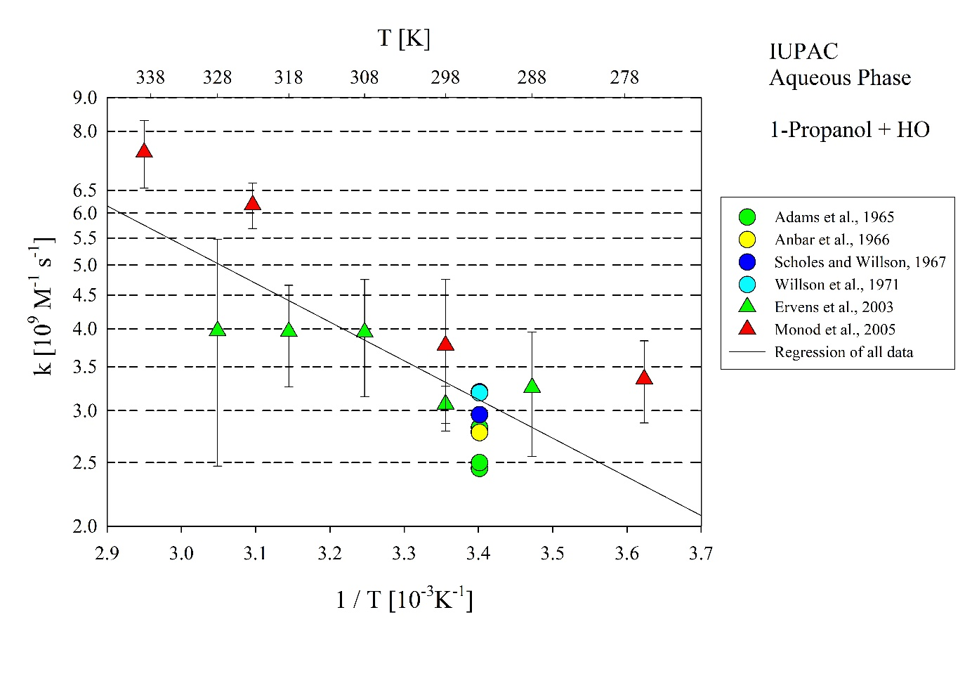 T-dependent rate constants for the reaction of 1-Propanol with HO in aqueous solution. Regression uses all data plotted in the Figure.

