IUPAC Task Group on Atmospheric Chemical Kinetic Data Evaluation – Data Sheet CGI_23
Datasheets can be downloaded for personal use only and must not be retransmitted or disseminated either electronically or in hardcopy without explicit written permission. The citation for this data sheet is: IUPAC Task Group on Atmospheric Chemical Kinetic Data Evaluation, (http://iupac.pole-ether.fr).
This datasheet last evaluated: July 2017; last change in preferred values: July 2017

CH₂OO + CF₃C(O)OH → products

Rate coefficient data

k/cm³ molecule⁻¹ s⁻¹ | Temp./K | Reference | Technique/Comments
Absolute Rate Coefficients
(3.4 ± 0.3) × 10⁻¹⁰ | 294 | Chhantyal-Pun et al., 2017 | PLP-CRDS (a)
3.8 × 10⁻¹⁸ T² exp[(1620 ± 180)/T] + 2.5 × 10⁻¹⁰ | 240-340

Comments

- CH₂OO was produced by the reaction of CH₂I + O₂. CH₂I was generated by 248-nm laser photolysis of diiodomethane, CH₂I₂. Time-resolved direct detection of CH₂OO by CRDS at 355 nm in the temperature range 240 – 340 K. The measured decay constant of CH₂OO, which was linearly dependent on (excess) concentrations of trifluoroacetic acid (up to 3.6 × 10¹⁴ molecule
cm⁻³), was used to determine the rate coefficient. The uncertainty limits are 95%. The rate coefficients were independent of pressure over the range 13 – 130 mbar and H/D substitution had no effect on k at all temperatures in the range studied.

Preferred Values

Parameter | Value | T/K
k /cm³ molecule⁻¹ s⁻¹ | 3.3 × 10⁻¹⁰ | 298
k /cm³ molecule⁻¹ s⁻¹ | 3.8 × 10⁻¹⁸ T² exp(1620/T) + 2.5 × 10⁻¹⁰ | 240-340

Reliability
Δ log k | ± 0.2 | 298
Δ E/R | ± 500 | 240-340

Comments on Preferred Values
The reaction of CH₂OO with trifluoroacetic acid at 294 K is extremely rapid, as found for reactions with other carboxylic acids (see data sheets CGI_10 and CGI_11). The rate coefficient decreases with increasing temperature in the range 240-340 K, and exceeds the estimates for collision-limited values. This suggests rate enhancement by capture mechanisms, attributable to the large permanent dipole moments of the two reactants. However, the observed temperature dependence is steeper than predicted by a simple dipole capture model with computed dipole moments. A different model involving competitive stabilization of a pre-reactive complex, binding the two reactants by two H-bonds, is proposed to explain the temperature dependence. This model was used in computational studies to describe the temperature dependence of the CH₂OO + HCOOH reaction (Long et al., 2009), which predicts an overall T-dependence of the form,
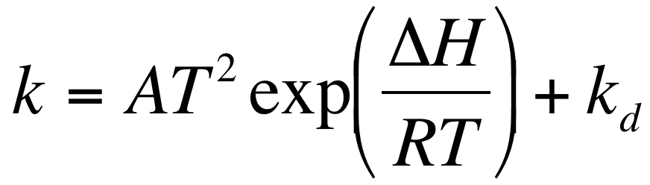
where the first term describes the complex-forming reaction, and k_{d} is the rate coefficient for the direct (non complex-forming) reaction, approximated to be temperature-independent. The recommended parameters for CH₂OO + CF₃C(O)OH are based on a fit to the experimental data, as reported by Chhantyal-Pun et al. (2017) using this model.

References

Chhantyal-Pun, R., McGillen, M. R., Beames, J. M., Khan, M. A. H., Percival, C. J., Shallcross, D. E., and Orr-Ewing, A. J.: Angew. Chem. Int. Ed., 56, 9044, 2017.
Long, B., Cheng, J. R., Tan, X. F., Zhang, W. J.: J. Mol. Struct. Theochem., 916, 159, 2009.

