IUPAC Task Group on Atmospheric Chemical Kinetic Data Evaluation – Data Sheet CGI_18
Datasheets can be downloaded for personal use only and must not be retransmitted or disseminated either electronically or in hardcopy without explicit written permission. The citation for this data sheet is: IUPAC Task Group on Atmospheric Chemical Kinetic Data Evaluation, (http://iupac.pole-ether.fr).
This datasheet last evaluated: February 2020; last change in preferred values: February 2020

(CH₃)₂COO + SO₂ → products

Rate coefficient data

k/cm³ molecule⁻¹ s⁻¹ | P/mbar | Temp./K | Reference |  | Technique/Comments
Absolute Rate Coefficients
k∞ = (1.32 ± 0.13) × 10⁻¹⁰ | >133 | 298 | Huang et al., 2015 |  | PLP-LPUVA (a)
(1.32 ± 0.02) × 10⁻¹⁰ [M] | 13-1030 | 298
(4.88 ± 0.32) × 10¹⁷ + [M]
k∞ = (1.90 ± 0.19) × 10⁻¹⁰ | 400 | 283 | Smith et al., 2016 |  | PLP-LPUVA (b)
k∞ = (1.53 ± 0.15) × 10⁻¹⁰ | 400 | 293
k∞ = (1.26 ± 0.13) × 10⁻¹⁰ | 400 | 303
(7.3 ± 5.0) × 10⁻¹¹ | 5.3 (He) | 298 | Chhantyal-Pun et al., 2017 |  | PLP-PIMS (c)
(1.5 ± 0.5) × 10⁻¹⁰ | 13 (He) | 298
k∞ = (2.2 ± 0.1) × 10⁻¹⁰ | 67-133 | 293 |  |  | PLP-CRDS (c)

Comments

- (CH₃)₂COO was generated from pulsed photolysis at 248 nm (KrF excimer laser) of a gaseous mixture consisting of (CH₃)₂CI₂, O₂ and buffer gas (N₂). (CH₃)₂COO was monitored by UV absorption in the region 300 – 450 nm, corresponding to the B̃ (1A′) ← X̃(1A′) electronic transition.. (CH₃)₂COO decay kinetics were determined by recording the time-resolved UV absorption spectrum, after correction for other absorbers. IO, which is formed from a second channel of the reaction of iodoalkyl radicals with O₂, was also detected. The dependence of the first-order decay constants on [SO₂] was used to determine k, the values of which were independent of total pressure above 133 mbar (100 Torr). At lower pressures, the rate constant declined with pressure. This was attributed to participation of an unstable adduct formed in the reaction which can be collisionally stabilized. A simple Lindemann-Hinshelwood energy transfer model did not give a good fit to the pressure dependence. The empirical expression cited above, together with the value for the high-pressure limiting rate constant, k∞, were reported.
- (CH₃)₂COO was generated from pulsed photolysis of a gaseous mixture consisting of (CH₃)₂CI₂, O₂ and buffer gas (N₂) at 248 nm. Total pressure was 400 mbar, to ensure measurements of k were at the high pressure limit (i.e. k∞). (CH₃)₂COO was monitored by time-resolved UV absorption at 340 nm, due to the B̃ (1A′) ← X̃(1A′) electronic transition. The amount of (CH₃)₂COO formed was estimated using a cross-section, σ = 1.6 × 10⁻¹⁷ cm² at 340 nm. Kinetic decays were recorded in the presence of different [SO₂], in the temperature range 283-303 K. The decay kinetics were pseudo-first order, and values of k∞ were determined from the variation of the first-order decay constants with [SO₂]. The value of k∞ exhibited a negative temperature dependence, (E/R = -1760 K).
- (CH₃)₂COO was formed by laser photolysis of (CH₃)₂CI₂ in the presence of O₂, and characterized by synchrotron photoionization mass spectrometry (PIMS) and ultraviolet absorption cavity ringdown spectrometry (CRDS). The cited measurements of k were obtained under pseudo-first order conditions in He buffer gas, using PIMS. Additional measurements at 293 K and a series of higher pressures (between 13 mbar and 133 mbar in N₂) using CRDS yielded larger rate coefficients, in the range (1.84 ± 0.12) × 10⁻¹⁰ to (2.29 ± 0.08) × 10⁻¹⁰ cm³ molecule⁻¹ s⁻¹. The tabulated limiting value at high pressure (k∞) was reported, based on the measurements between 67 and 133 mbar N₂. The reaction of (CD₃)₂COO with SO₂ was also studied at 4 Torr using PIMS. The results showed an inverse kinetic isotope effect with the deuterated rate coefficient, (1.37 ± 0.12) × 10⁻¹⁰ cm³ molecule⁻¹ s⁻¹, approximately twice that for the un-deuterated reaction. It was suggested that this could reflect more effective collisional stabilization of the deuterated association complex because of the increased density of vibrational states.

Preferred Values

Parameter | Value | T/K
k∞/ cm³ molecule⁻¹ s⁻¹ | 1.55 × 10⁻¹⁰ | 298
k∞/ cm³ molecule⁻¹ s⁻¹ | 4.23 × 10⁻¹³ exp(1760/T) | 280-305
Reliability
Δ log k∞ | ± 0.15 | 298
Δ (E/R) | ± 500 | 280-305

Comments on Preferred Values
The preferred values are based on all the tabulated studies, in which the rate coefficients were measured by direct kinetic methods. At pressures above about 133 mbar (100 Torr), k was found to be independent of pressure, and there is reasonable consistency in the results from the three studies. The preferred value of (E/R) is based on the data of Smith et al. (2016). The 298 K preferred value of k∞ is the average of values reported at or near 298 K in the three studies, corrected for temperature where necessary using the preferred value of (E/R). It is noted that the rate coefficients measured by Chhantyal-Pun et al. (2017) are larger than those reported for similar conditions in the other studies (e.g. by about 40−50 % for k∞), and this is reflected in the reliability assigned to the 298 K preferred value.
The studies of Huang et al. (2015) and Chhantyal-Pun et al. (2017) demonstrate that the value of k falls off at pressures below about 133 mbar (100 Torr). However, the decrease between 133 mbar and 13 mbar reported by Huang et al. (2015) (about a factor of two) is much greater than that reported by Chhantyal-Pun et al. (2017) (about 20 %). At present, therefore, we make no recommendation for the pressure dependence.
Chhantyal-Pun et al. (2017) also observed the production of SO₃, in experiments at 13 mbar using PIMS. The rise time of SO₃ was found to agree reasonably well with the observed decay of (CH₃)₂COO, confirming that SO₃ is a direct product of the reaction. Steady state kinetics studies in which loss of SO₂ (Newland et al., 2015) and formation of H₂SO₄ (Berndt et al., 2014) were measured during the ozonolysis of 2,2-dimethyl-but-2-ene give broadly similar relative rate constants, consistent with SO₃ formation remaining an important pathway at atmospheric pressure.
Quantum chemical studies predict that the reaction of (CH₃)₂COO with SO₂ proceeds via barrierless formation of a chemically-activated cyclic secondary ozonide (Vereecken et al. 2012), and the near gas-kinetic experimental rate coefficient is consistent with this. The pressure dependence arises from the decomposition of the chemically-activated secondary ozonide back to reactants occurring in competition with its collisional stabilization. Decomposition via other routes (e.g. directly to CH₃C(O)CH₃ and SO₃) may also compete with collisional stabilization, although stabilization is calculated to be efficient and dominant under atmospheric conditions. Further studies are required to characterize the reactions of the stabilized secondary ozonide, although the investigations of the ozonolysis of 2,2-dimethyl-but-2-ene at atmospheric pressure (e.g. Berndt et al., 2014; Newland et al., 2015) suggest that this must also form CH₃C(O)CH₃ and SO₃, at least partially. Veereecken et al. (2012) speculated that water-catalysed conversion of the longer-lived stabilized secondary ozonide into methyl acetate (CH₃C(O)OCH₃) + SO₂ might also be accessible, although further work is clearly required to confirm this. At present, we make no firm recommendations for product channel contributions, and await until additional theoretical and quantitative experimental product channel data.

References

Berndt, T., Jokinen, T., Sipilä, M., Mauldin, R. L., Herrmann, H., Stratmann, F., Junninen, H. and Kulmala, M.: Atmos. Environ., 89, 603, 2014.
Chhantyal-Pun, R., Welz, O., Savee J. D., Eskola, A. J., Lee, E. P. F., Blacker, L., Hill, H. R., Ashcroft, M., Khan, M. A. H., Lloyd-Jones, G. C., Evans, L., Rotavera, B., Rotavera H., Osborn, D. L., Mok, D. K. W., Dyke, J. M., Shallcross, D. E., Percival, C. J., Orr-Ewing, A. J. and Taatjes, C. A.: J. Phys. Chem. A, 121, 4, https://doi.org/10.1021/acs.jpca.6b07810, 2017.
Huang, H.-L., Chao, W. and Lin, J. J.-M.: Proc. Natl. Acad. Sci., 112(35), 10857, doi: 10.1073/pnas.1513149112, 2015.
Smith, M. C., Chao, W., Takahashi, K., Boering, K. A. and J. J.-M.: J. Phys. Chem. A, 120(27), 4789, 2016.
Newland, M. J., Rickard, A. R., Alam, M. S., Vereecken, L., Muñoz, A., Rod́enas, M. and Bloss, W. J.: Phys. Chem. Chem. Phys., 17, 4076, 2015.
Vereecken, L., Harder, H. and Novelli, A.: Phys. Chem. Chem. Phys., 14, 14682, 2012.

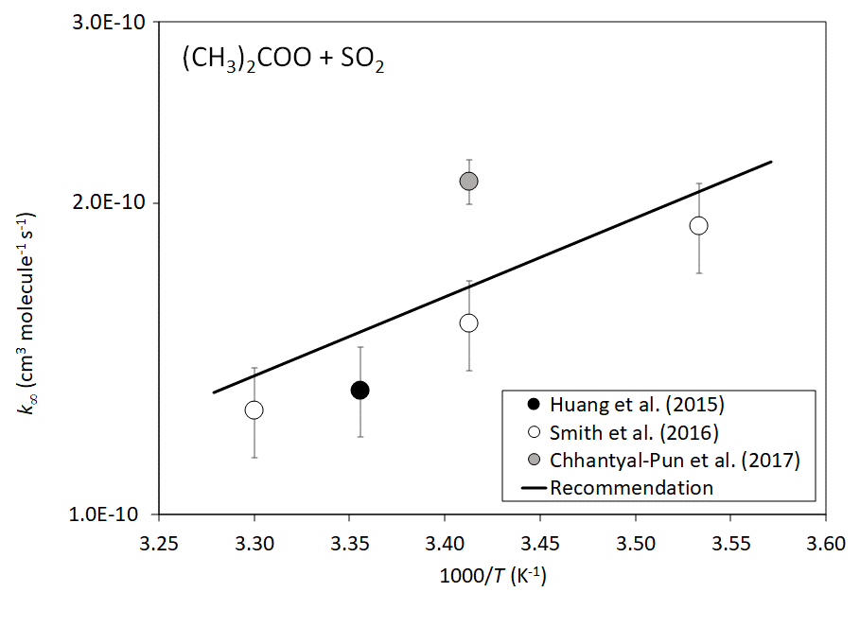
Arrhenius plot of k∞((CH₃)₂COO + SO₂). The displayed errors are the experimental limits cited by the authors.

